­­

Business Practice Manual for

Direct Telemetry

Version 12.0

Revised: March 3, 2019

**Approval History**

Approval Date : August 2, 2011

Effective Date : August 2, 2011

BPM Owner : Heather Kelley

BPM Owner’s Title : Director, Market Services

**Revision History**

| Version | PRR | Date | Description |
| --- | --- | --- | --- |
| 12 | 1151 | 03/04/2019 | Section 4 has been accommodated to include an Internet Service Provider Communication option.  Section 8.4 Temporary Telemetry Exemption sections has been updated with new exemption requirements. |
| 11.0 | 1054 | 05/02/2018 | Removed ECN requirement for resources 400MW or greater. Clarified maximum of 1200MW per connection aggregating up to 25 resources. Consolidated descriptions of real-time communications options into a single section (5.3). Moved prior section 14 (ISO Security) into section 4.4 to consolidate all security topics under section 4 (Communications), including PKI and ECN agreements and Connected Entity Service Guides. Recharacterized RIG as any Real-Time Device that can meet ISO functional, operational, and security objectives. Added Dispersive™ CISDN communications option. Added table of acronyms. Added table of exhibits, figures, and diagrams. Modified multiple diagrams. Non-Spinning Reserve Logic and Testing (previously section 11). Removed redundant Communication Technical Principles (previous section 13.4). |
| 10 | 942 | 01/05/2017 | Minor edits to section 3.2.2.1, changes to Section 6.7 DNP3 Variation type, 7.1 Point Matrix. In section 10.7 and 10.12 email address is updated. New section 10.9 RIG data validation is added. 10.12 RIG Generation Acceptance test and 10.13 Final RIG Documentation sections has been removed. Changes to 17.2.2 UCON  definition. New section 17.5 Battery point definitions are added. |
| 9 | 895 | 3/10/2016 | PRR 895 - Changes to Section 6.2.2 and 6.2.3 regarding PDR requirements. Change to Section 6.9 to update EIR RIG limit to 1200MW. Change to Section 12.4 to include SPIN Reserve Testing. Complete replacement of Section 14 to provide updated PDR Direct Telemetry Requirements. |
| 8 | 832 | 5/29/2015 | PRR 832 – Changes to Section 6.2.2 to add language regarding PDR Timing Requirements. |
| 7 | 821 | 3/26/2015 | PRR 821 - Added deadline for Wind/Solar site information form to paragraphs 13.4.2 and 13.5.4. Corrected reference to solar in paragraph 13.5.4. Removed Tables 13.4.2 and 13.5.4. Updated link for Network Connectivity Security Requirements and ECN Agreement in Section 10.6. |
| 6 | 770 | 8/06/2014 | Added clarifying language and site information form links to section 13 Eligible Intermittent Resources (EIR), subsections 13.1 to 13.5 and combined sections 13.6 with 13.5. Added updated language to section 10. FNM Database Process and RIG Installation |
| 5 | 726 | 4/03/2014 | Added language to section 6.10 exempting DRP’s from the RIG aggregation location limitation in the provision of real-time telemetry data for Proxy Demand Resources (PDR) (PRR 726) |
| 4 | 719/725 | 3/21/2014 | Added clarifying language indicating that Reliability Demand Response Resources (RDRR) are not required to provide telemetry and therefore exempt from direct telemetry requirements to section 2.1 (PRR 725) |
| 3 | 633 | 11/14/2012 | Removal of the Full Network Model time line guide and changes to EIR less than 10MW. |
| 2 | 489 | 12/14/2011 | Added requirement for data quality flag propagation as new Section 6.8, added requirement for preliminary revenue metering package to Section 10.2, removed unnecessary definitions from Section 4, and made changes to ISP circuit exceptions in Section 5.3 per BPM PRR 489. Effective Date 12/01/11. |
| 1 |  | 8/02/2011 | Initial BPM submittal document |

**TABLE OF CONTENTS**

1. Introduction 16

1.1 Purpose of ISO Business Practice Manuals 16

1.2 Purpose of This Business Practice Manual 16

1.3 Organization of This Business Practice Manual 16

1.4 References 17

2. ISO Direct Telemetry 20

2.1 Direct Telemetry Process 20

2.2 Real-Time Device Defined 20

2.2.1 Remote Intelligence Gateway (RIG) Historically 21

2.2.2 Data Processing Gateway (DPG) Deprecated 21

2.2.3 RIG Re-characterized as Real-Time Device 21

2.3 Installation and Validation of Direct Telemetry 22

2.4 Flow of Real-Time Data 23

3. ISO Responsibilities 25

3.1 Overview of ISO Responsibilities 25

3.2 Exceptions to Direct Telemetry 25

3.3 Direct Telemetry Validation 25

3.3.1 Overview of Telemetry Installation Validation Process 26

3.3.2 ISO Certification Responsibilities 28

3.3.3 Documentation Requirements 28

3.3.4 ISO Review of Documentation 30

4. Communications 31

4.1 Overview of Communications Objectives 31

4.2 Choice of Connection Methods 31

4.3 Communication Context Diagram 32

4.4 Main Communication Options 34

4.5 Detailed Communication Options 34

4.6 Ruggedized Gateway Available 38

4.7 ISO Security for Direct Telemetry 39

4.7.1 Data Confidentiality 39

4.7.2 Network Security Principles and Best Practices 39

4.7.3 Communication Security Characteristics 40

4.7.4 Communication Security Protocols 42

4.7.5 Communication and ECN Agreements 42

4.7.6 Connected Entity Service Guides 43

4.8 Reliability 44

4.8.1 Redundant Circuits 44

4.8.2 Data Validation 44

4.8.3 Voice Communications 45

4.8.4 Communications During Telemetry Failure 45

5. Operational Telemetry Requirements 46

5.1 Unit Telemetry Visibility 46

5.2 Performance Monitoring 46

5.2.1 Direct Telemetry Timing Requirements 46

5.2.2 PDR Timing Requirements 47

5.2.3 PDR Reading Requirements 48

5.3 ISO Real-Time Communication Technical Design Options 48

5.3.1 Functional Components of Real-Time Communication Options 49

5.3.2 Transport Options 50

5.3.3 Transport Conceptual Diagrams 50

5.3.4 Direct Telemetry Hardware Options 55

5.4 ISO EMS Interrogations 59

5.5 DNP3 Object and Variation Types for Real-Time Device Responses 60

5.6 Quality Flag Propagation to DNP3 60

5.7 Maximum MW Real-Time Device Limitation 61

5.8 Real-Time Device Location Requirements 62

5.9 Real-Time Device Market Resource Limitation 62

5.10 Cost Responsibility 62

6. Telemetry Data Points List 63

6.1 Point Matrix 63

6.2 Analog and Digital Notes 70

7. Availability and Maintenance 71

7.1 ISO Reliability Requirements 71

7.2 ISO-Controlled Grid Operation and Market Availability Requirement 71

7.3 Real-Time Device Operation and Maintenance 72

7.3.1 Coordination of Changes to the Real-Time Device 72

7.3.2 Database Configuration and Management Affecting the ISO’s EMS 74

7.3.3 Routine Testing and Maintenance of Real-Time Devices 74

8. Real-Time Device Implementation 76

8.1 Engineering and Deployment 76

8.2 Real-Time Device Database Development 76

8.3 Telecommunication Circuit Installation and Power Requirements 76

8.4 Temporary Telemetry Exemptions 76

9. FNM Database Process and Real-Time Installation 80

9.1 ISO FNM Database Process 80

9.2 New Database Submission 80

9.2.1 Standards to Submit Real-Time Device Database for ISO Database Build 80

9.3 Real-Time Database Submittal Timeline 80

9.4 Network Physical Circuit Protection to the Resource 80

9.5 Network Circuit Provisioning and Monitoring 80

9.5.1 AT&T ECN or ANIRA IPsec VPN 80

9.5.2 Dispersive™ CISDN 81

9.5.3 Self-Maintained Network and Circuit Monitoring 81

9.6 Standards for Point-to-Point Testing with the ISO 81

9.7 Required Personnel for Point testing 83

9.8 Real-Time Device Data Validation 83

9.9 Upgrade or Replacement of a Real-Time Device 83

9.10 Outage Management for Meter or Real-Time Device work 84

9.11 Digital Certificates 85

9.12 Wind and Solar FNM Documentation Required 86

10. AGC Operational Requirements for Generating Units 87

10.1 Required DNP3 and Telemetry Data Points for AGC 87

10.2 AGC Control (Bumpless Transfer) 87

11. Eligible Intermittent Resources (EIR) 89

11.1 Applicability 89

11.2 Power Reliability Requirements 89

11.3 Basic Meteorological Data 89

11.3.1 Meteorological Wind Speed 89

11.3.2 Meteorological Wind Direction 89

11.3.3 Meteorological Barometric Pressure 89

11.3.4 Meteorological Ambient Temperature 89

11.4 Wind Generation 90

11.4.1 Meteorological Station Requirements 90

11.4.2 Designated Turbines 90

11.5 Solar Generation 90

11.5.1 Meteorological Station Requirements 90

11.5.2 Basic Solar Meteorological Data 91

11.5.3 Participating Generator Irradiance Component Requirements 91

11.5.4 Solar Technology Definitions 91

11.5.5 Solar Site Information Form and Topographical Map 92

12. Proxy Demand Resource (PDR) 93

12.1 PDR Point Requirements 93

12.1.1 Real Load MW 93

12.1.2 PDR Unit Connectivity Status (PDR UCON) 93

12.1.3 Bias Load 93

12.1.4 PDR Unit Ready to Start and Start Status 93

12.1.5 Pseudo Generation MW 93

12.1.6 Statuses and Pseudo Generation Flow 94

12.2 Timing and Configuration Requirements 96

12.3 Analog Data Requirements 96

12.3.1 Instantaneous Load (MW) 96

12.3.2 Pseudo Generation (MW) 96

12.4 Digital Data Requirements 99

12.4.1 Load Unit Connectivity Status (LOAD UCON) 99

12.5 PDR Unit Connectivity Status (PDR UCON) 100

13. Real-Time Device Aggregator 102

13.1 Applicability 102

13.2 Real-Time Device Aggregator Responsibility 102

13.3 Real-Time Device Aggregator Authorization 102

14. Real-Time Point Definitions 103

14.1 Analog Values 103

14.1.1 Unit Gross Megawatts (Gross MW) 103

14.1.2 Unit Net Megawatts (Net MW) 103

14.1.3 Unit Point of delivery Megawatts (POD MW) 104

14.1.4 Unit Auxiliary Load Megawatts (Aux MW) 104

14.1.5 Gross Reactive Power or Gross Mega VAR (MVAR) 105

14.1.6 Point of delivery Mega VAR (POD MVAR) 105

14.1.7 Net Reactive Power (Net MVAR) 105

14.1.8 Auxiliary Load Reactive Power (Aux MVAR) 106

14.1.9 Generating Unit Terminal Voltage (KV) 106

14.1.10 Unit Operating High Limit (UOHL) [AGC Units Only] 107

14.1.11 Unit Operating Lower Limit (UOLL) [AGC Units Only] 107

14.2 Digital Values 107

14.2.1 Unit Generator Breaker 107

14.2.2 Unit Connectivity Status (UCON) 108

14.2.3 Unit Control Status (UCTL) 108

14.2.4 ISO Unit Authority Switch (UASW) 109

14.2.5 Unit Automatic Generation Control (UAGC) 109

14.2.6 Automatic Voltage Regulator (AVR) / Power System Stabilizer (PSS) Status 110

14.2.7 Peaking Unit Ready to Start and Start Statuses 110

14.3 Switchyard Values 110

14.3.1 Switchyard Line and Transformer MW and MVAR Values 111

14.3.2 Switchyard Bus Voltage 111

14.3.3 Switchyard Device Status 111

14.3.4 Aggregated Units 112

14.3.5 Aggregated Gross MW and MVAR 112

14.3.6 Aggregated Net MW and MVAR 112

14.3.7 Aggregated Aux MW and MVAR 112

14.3.8 Aggregated Point of Delivery MW 112

14.3.9 Aggregated Point of Delivery MVAR 112

14.3.10 Aggregated Unit Connectivity (UCON) 112

14.3.11 Aggregated Peaking Unit Start and Ready to Start 112

14.4 Wind and Solar Point Definitions 113

14.4.1 Direct Irradiance (DIRD) 113

14.4.2 Global Horizontal Irradiance (GHIRD/GHI) 113

14.4.3 Global Irradiance / Plane of Array Irradiance (PAIRD) 113

14.4.4 Diffused Irradiance 113

14.4.5 Back Panel Temperature (BPTEMP) 114

14.5 Battery Point Definitions 114

14.5.1 Instantaneous State Of Charge (SOC) 114

14.5.2 Maximum Continuous Energy limit 114

15. Sub-LAP Resource Names 115

Exhibits and Tables

Exhibit 2‑1: Overview of Telemetry Installation and Validation 23

Exhibit 2‑2: Overview of Real-Time Telemetry Data Flow 24

Exhibit 3‑1: Telemetry Installation Validation Process 27

Exhibit 4-1: Context Diagram for Communications Options for Direct Telemetry 33

Table 4-2: Main Requirements for Each Communication Option for Direct Telemetry 34

Table 4-3: Detailed Comparison of Communication Options for Direct Telemetry 35

Exhibit 5-1: Timing of Telemetered Real-Time Data for Generators Providing Ancillary Services or Energy Only through a Real-Time Device 47

Exhibit 5-2: PDR Timing, 5- Minute Case 48

Exhibit 5-3: Transport Option – ECN with T1 Leased Circuit 51

Exhibit 5-4: Transport Option – Public Internet with ANIRA IPsec VPN Backhaul to ECN 52

Exhibit 5-5: Transport Option – Public Internet with Dispersive™ CISDN 53

Exhibit 5-6: Dispersive™ CISDN Hardware Option 55

Exhibit 5-7: Plant Control System Hardware Option 56

Exhibit 5-8: Plant Control System Hardware Option Functional Diagram 57

Exhibit 5-9: Real-Time Device Hardware Option 58

Exhibit 5-10: Real-Time Device Hardware Option Functional Diagram 58

Exhibit 5-11: Upstream and Downstream Device Identification 61

Table 6-1: Required Real-Time Points by Technology or Service 64

Exhibit 7-1: Operation and Maintenance Boundaries 72

Table 11-1: Meteorological Elements, Devices, Units, and Accuracy **Error! Bookmark not defined.**

Table 11-2: Minimum Required (R) Measurement of Solar Irradiance and Backplane Temperature **Error! Bookmark not defined.**

Table 12-1: Sequence of ADS Signal for PDR 94

Exhibit 12-2: Calculations for Pseudo Generation 95

Exhibit 12-3: PDR UCON Status Flowchart 98

Exhibit 12-4: Load UCON Status Flowchart 99

Exhibit 12-5: PDR UCON Status Flowchart 101

Table 15-1: Sub-LAP Resource Names 115

ACRONYMS

Refer to this table for acronyms used throughout this document.

| **ACRONYM** | **ACRONYM EXPANSION** |
| --- | --- |
| ACL | Access Control List |
| ADS | Automated Dispatch System |
| AES | Advanced Encryption Standard |
| AGC | Automatic Generation Control |
| API | Application Programming Interface |
| AT&T | American Telephone and Telegraph |
| AVPN | AT&T Virtual Private Network |
| AVR | Automatic Voltage Regulator |
| BPM | Business Practice Manual |
| BPTEMP | Back Panel Temperature |
| CIP | Critical Infrastructure Protection |
| CISDN | Critical Infrastructure Software-Defined Network |
| CSR | Certificate Signing Request |
| DDC | Direct Digital Control |
| DDoS | Distributed Denial of Service |
| DER | Distributed Energy Resource |
| DERA | Distributed Energy Resource Aggregate |
| DERP | Distributed Energy Resource Provider |
| DIFGH | Global Diffused Irradiance |
| DIRD | Direct Irradiance |
| DNI | Direct Normal Irradiance |
| DNP3 | Distributed Network Protocol (Version 3) |
| DPOA | Diffused Plane of Array |
| DRP | Demand Response Provider |
| DVN | Dispersive™ Virtual Network |
| ECN | Energy Communication Network |
| EIR | Eligible Intermittent Resource |
| EIRP | Eligible Intermittent Resource Protocol |
| EMS | Energy Management System |
| FERC | Federal Energy Regulatory Commission |
| GHI | Global Horizontal Irradiance |
| GHIRD | Global Horizontal Irradiance |
| HVP | High Voltage Protection |
| IED | Intelligent Electronic Device |
| IEEE | Institute of Electrical and Electronics Engineers |
| IPsec | Internet Protocol Security |
| ISO | California Independent System Operator |
| LAN | Local Area Network |
| LAP | Load Aggregation Point |
| LEC | Local Exchange Carrier |
| LIDAR | Light Detection and Ranging or Light Imaging, Detection, and Ranging |
| MitM | Machine in the Middle |
| MPLS | Multi-Protocol Label Switching |
| MOD | Motor Operated Disconnect |
| MPOE | Main Point of Entry |
| MWh | Megawatt Hours |
| NERC | North American Electric Reliability Corporation |
| NIST SP | National Institute of Standards and Technology Special Publication |
| O&M | Operation and Maintenance |
| OPC | Object Linking and Embedding for Process Control |
| PAIRD | Plane of Array Irradiance |
| PCMCIA | Personal Computer Memory Card International Association |
| PDR | Proxy Demand Resource |
| PKI | Public Key Infrastructure |
| PIR | Participating Intermittent Resource |
| POD | Point of Delivery |
| PSS | Power System Stabilizer |
| RDRR | Reliability Demand Response Resource |
| RFC | Request for Comment |
| RIG | Remote Intelligence Gateway |
| SaaS | Software as a Service |
| SCADA | Supervisory Control and Data Acquisition |
| SDN | Software-Defined Network |
| SD-WAN | Software-Defined Wide-Area Network |
| SOC | State Of Charge |
| SODAR | Sonic Detection And Ranging |
| SSL | Secure Sockets Layer |
| T1 | Trunk Level 1 |
| TCP | Transmission Control Protocol |
| TLS | Transport Layer Security |
| UAGC | Unit Automatic Generation Control |
| UASW | Unit Authority Switch |
| UCON | Unit Connectivity |
| UCTL | Unit Control Switch |
| UDP | User Datagram Protocol |
| UOHL | Unit Operating High Limit |
| UOLL | Unit Operating Lower Limit |
| VPN | Virtual Private Network |
| WAN | Wide Area Network |
| WECC | Western Electricity Coordinating Council |
| VER | Variable Energy Resource as defined by FERC |
| WON | WECC Operations Network |
| X.509 | X.509 is not an acronym but refers to a format for digital certificates as described in RFC 5280 |

# Introduction

The ISO’s Business Practice Manual for Direct Telemetry provides implementation detail, consistent with the ISO Tariff, for establishing Participating Generators to establish direct telemetry with the ISO’s Energy Management System (EMS).

## Purpose of ISO Business Practice Manuals

The Business Practice Manuals (BPMs) developed by ISO are intended to contain implementation detail consistent with and supported by the ISO Tariff, including instructions, rules, procedures, examples, and guidelines for the administration, operation, planning, and accounting requirements of the ISO and ISO energy markets. See ISO Business Practice Manuals in References for a link to the BPM library. Updates to all BPMs are managed in accordance with ISO Change Management procedures.

## Purpose of This Business Practice Manual

The BPM for Direct Telemetry covers the responsibilities of the ISO, Participating Generators, Participating Loads, Proxy Demand Resources, and Scheduling Coordinators representing these entities for telemetry installation, validation, and maintenance, in addition to the telemetry data required.

The provisions of this BPM are intended to be consistent with the ISO Tariff. If any provisions of this BPM are found to be in conflict with the ISO Tariff, the ISO is nevertheless bound to operate in accordance with the ISO Tariff. Any summarization or repetition of any provision of the ISO Tariff in this BPM is intended only to aid understanding. Even though the ISO will make every effort to maintain the information contained in this BPM and to notify Market Participants of changes, it is the responsibility of every Market Participant to ensure compliance with the most recent version of this BPM and to comply with all applicable provisions of the ISO Tariff. Any reference in this BPM to the ISO Tariff, a given agreement, or any other BPM or instrument, is intended to refer to the ISO Tariff, that agreement, or BPM or instrument as modified, amended, supplemented, or restated.

The captions and headings in this BPM are intended solely to facilitate reference and not to have any bearing on the meaning of any of the terms and conditions.

## Organization of This Business Practice Manual

This Business Practice Manual describes the responsibilities of the ISO, Participating Generators, Participating Loads, Proxy Demand Resources, and Scheduling Coordinators representing these entities for provision of direct telemetry, including provisions for configuration, installation, and validation of telemetry facilities for resources providing Ancillary Services or Energy only, and for wind, solar, and Proxy Demand Resources.

## References

The following table provides links and references used throughout this Business Practice Manual.

| **TOPIC** | **REFERENCE** |
| --- | --- |
| AT&T Connected Entity Service Guide | <https://www.caiso.com/Documents/EstablishECNConnectivity-ConnectedEntityServiceGuide.pdf> |
| Acceptance Testing for Real-Time Devices | <http://www.caiso.com/Documents/RIGAcceptanceTest_RAT_Procedures.pdf> |
| Acceptance Testing for Real-Time Devices | <http://www.caiso.com/Documents/RIGAcceptanceTest_RAT_Procedures.pdf> |
| Certificate Practice Statement for Basic Assurance Certification Authority | <http://www.caiso.com/Documents/CertificationPracticeStatement_BasicAssuranceCertificationAuthority.pdf> |
| E-mail Addresses for Submitting a Certificate Signing Request | [CertificateRequests@caiso.com](mailto:CertificateRequests@caiso.com) [EDAS@caiso.com](mailto:EDAS@caiso.com) |
| Establishing Dispersive™ CISDN Connectivity with the ISO | <https://www.caiso.com/Documents/EstablishDispersiveCISDNConnectivitywithISO.pdf> |
| Fieldwork Appointment Request | <http://www.caiso.com/fieldworksupport/Pages/default.aspx> <http://www.caiso.com/Documents/FieldworkSupportRequests.pdf> |
| Guide to Industrial Control Systems (ICS) Security | <http://nvlpubs.nist.gov/nistpubs/SpecialPublications/NIST.SP.800-82r2.pdf> |
| ISO Business Practice Manuals | <https://www.caiso.com/rules/Pages/BusinessPracticeManuals/Default.aspx> |
| ISO Energy Data Acquisition Specialist E-mail Address | [EDAS@caiso.com](mailto:EDAS@caiso.com) |
| ISO Energy Data Acquisition Specialist Phone Number | (916) 608-5826 |
| ISO Tariff | <https://www.caiso.com/rules/Pages/Regulatory/Default.aspx> |
| ISO documentation on Outage Coordination | <http://www.caiso.com/market/Pages/OutageManagement/Default.aspx> |
| ISO Direct Telemetry Web Page | <http://www.caiso.com/participate/Pages/MeteringTelemetry/Default.aspx> |
| Information Security Requirements for the Energy Communication Network (ECN) | <http://www.caiso.com/documents/californiaisoinformationsecurityrequirements_theenergycommunicationsnetwork.pdf> |
| Network Connectivity Security Requirements and Agreement | <https://www.caiso.com/Documents/EnergyCommunicationNetworkConnectivitySecurityRequirements-Agreement_RemoteIntelligentGatewayDevices.pdf> |
| New Resource Implementation Contact | [NewResourceImplementation@caiso.com](mailto:NewResourceImplementation@caiso.com) |
| New Resource Implementation Timeline | <http://www.caiso.com/participate/Pages/Generation/Default.aspx> |
| Request Form for Digital Certificate for Real-Time Device | <https://www.caiso.com/Documents/DeviceCertificateRequestForm.xls> |
| Solar Site Information Spreadsheet | <http://www.caiso.com/Documents/SolarSiteInformation.xlsx> |
| Wind Site Information Spreadsheet | <http://www.caiso.com/Documents/WindSiteInformation.xls> |

# ISO Direct Telemetry

This section includes a description of the telemetry process, a diagram of the telemetry installation and validation process, and a diagram of the flow of telemetry data.

## Direct Telemetry Process

This BPM sets forth requirements for the provision of real-time data to the ISO applicable to all Generating Units of Participating Generators providing Ancillary Services (including Regulation) or Energy in the ISO’s markets. This BPM describes the process and procedures used by the ISO to obtain real-time data from the resources of Participating Generators, Participating Loads, Proxy Demand Resources, and Scheduling Coordinators representing these entities for operating the ISO Balancing Authority Area reliably and balancing the ISO’s markets. This BPM does not apply to Reliability Demand Resources, which have no requirement to provide telemetry. This BPM does not apply to the Inter-Control Center Communications Protocol (ICCP – IEC60870-6 TASE.2) that utility Control Centers use exchange real-time data, schedule, and control commands.

A Generator with a Generating Unit connected to the electric grid within the ISO Balancing Authority Area that (1) has a capacity of ten (10) megawatts (MW) or greater and is not exempt pursuant to the ISO Tariff, or (2) provides Ancillary Services, or (3) is an Eligible Intermittent Resource not exempt pursuant to the ISO Tariff must install, in accordance with the requirements specified in this BPM, equipment and/or software that can interface with the ISO’s Energy Management System (EMS) to supply telemetered real-time data. Real-Time Devices, as defined below, will serve as the primary means for secure communications and direct control between the Generator’s Generating Unit and the CAISO’s EMS as a prerequisite for participation in any of the CAISO markets requiring real-time data. In some circumstances, the CAISO allows for aggregation of Generating Units and the associated direct telemetry. While this BPM does not address all issues related to Aggregated Units, it does address the required points for Aggregated Units herein. The resources of Participating Loads and Proxy Demand Resources are also subject to these requirements for telemetry of real-time data.

## Real-Time Device Defined

This Business Practice Manual uses the term Real-Time Device to refer to any DNP3-capable Intelligent Electronic Device (IED) that meets ISO requirements for real-time data and has the ability to monitor processes, provide advanced local control intelligence, and communicate directly to a SCADA system or an EMS. DNP3 (Distributed Network Protocol, Version 3) refers to IEEE Standard 1815-2012 for Electric Power Systems Communications). A Real-Time Device is a combination of software and optionally hardware that achieves ISO requirements for direct telemetry of a Participating Generator. A Real-Time Device may also include power system protection functions. Types of Real-Time Devices include RTUs, Protection Systems, Load Profile Metering (Revenue Metering), PLCs, Load Balancers, SCADA systems, DNP3 protocol drivers, and database historians.

### Remote Intelligence Gateway (RIG) Historically

Historically, the ISO has required a Participating Generator to install a Remote Intelligence Gateway (RIG) to provide direct telemetry. Conceptually, a RIG is a protocol converter and a security gateway to the ISO’s EMS; for example, a RIG could convert DNP3 over serial to DNP3 over TCP/IP then encapsulate the result in an SSL/TLS tunnel. Some Participating Generators choose to provide their own RIGs and some choose to work with third parties that provide RIG engineering services. The ISO has maintained on its Web site a list of third-party RIG engineering firms. The ISO does not endorse or certify any of the firms on this list, does not make any warranty or representation regarding these firms or their capability to provide engineering services related to a project, and has not restricted the Participating Generator’s selection of a firm to the firms on this list.

### Data Processing Gateway (DPG) Deprecated

Historically, the ISO used a Data Processing Gateway (DPG) for non-AGC Generating Units and allowed DPG connections over both the ECN and the public Internet using SSL/TLS digital certificates issued by the ISO. At the time, RIGs protected AGC Generating Units over the ECN only and used PCMCIA cards to provide the SSL channel.

Over time, RIGs adopted digital certificates instead of PCMCIA cards and the distinction between RIGs and DPGs blurred. RIG SCADA functionality also advanced compared to DPG SCADA functionality. Consequently, the ISO deprecated DPGs.

As participation in the ISO grew, branded RIGs served a valuable purpose in connecting more Participating Generators to the ISO. Now, with advances in technology, Participating Generators have more flexibility to implement a variety of devices that meet ISO security and operational objectives.

### RIG Re-characterized as Real-Time Device

The ISO would like to provide Participating Generators as much flexibility as possible in connecting to the ISO EMS securely while meeting operational objectives for real-time telemetry. The ISO is also determined to lower barriers to entry for participation in ISO energy markets while ensuring the collection of accurate data. Accordingly, the ISO has re-characterized a RIG as any Real-Time Device that meets the security and operational objectives for direct telemetry.

The Real-Time Device is a system for collection and transmission of data between the ISO's EMS and Participating Generators. These devices provide the ability, in real time, to collect data and distribute supervisory control commands to and from generators as well as transfer this data to and from multiple central monitoring and supervisory control sites. Data encryption assures confidentiality of participant data and also provides assurance that a Participating Generator reliably receives ISO SCADA instructions according to their participation agreements. Device security has typically relied on the ISO's PKI and ECN, but secure options are now available to Participating Generators over the public Internet without requirement for ISO-issued digital certificates that Participating Generators need to manage at installation, periodical renewal, or replacement upon major changes in risk level such as SSL3 deprecation, the compromise of 1024-bit certificates, or the weakness of certificates signed using the SHA1 algorithm (all of which can be very impactful to Participating Generators). Historically, the ISO has required that Real-Time Devices communicate with the ISO's EMS over the ECN. With equivalent and even superior security and reliability options now available over the public Internet, the ISO has expanded telemetry options, as described in this BPM.

With this recharacterization of RIG as a Real-Time Device:

* The ISO no longer maintains a list of validated RIGs that use standard real-time telemetry components.
* The ISO will accept any Real-Time Device that can connect through a TCP/IP connection to the ISO’s EMS using DNP3 Level 1 communications.
* The ISO no longer maintains a list of third-party RIG engineering firms.
* The ISO does not limit Participating Generators to a specific list of vendors.
* The ISO is open to any way of connecting to a Participating Generator’s current control system and communication infrastructure to communicate to the ISO EMS as long as the Participating Generator meets the security and operational objectives for direct telemetry.

This BPM provides information regarding:

* The ISO installation requirements for Participating Generator facilities;
* How the ISO validates direct telemetry facilities for Participating Generators, Participating Loads, PDRs, and the SCs representing these entities; and
* Validation, testing, and maintenance requirements for direct telemetry for Participating Generators’ facilities participating in the ISO markets.

## Installation and Validation of Direct Telemetry

Exhibit 2-1 illustrates the process for telemetry installation and validation for a Participating Generator that is required to provide real-time direct telemetry to the ISO.

Exhibit 2‑1: Overview of Telemetry Installation and Validation

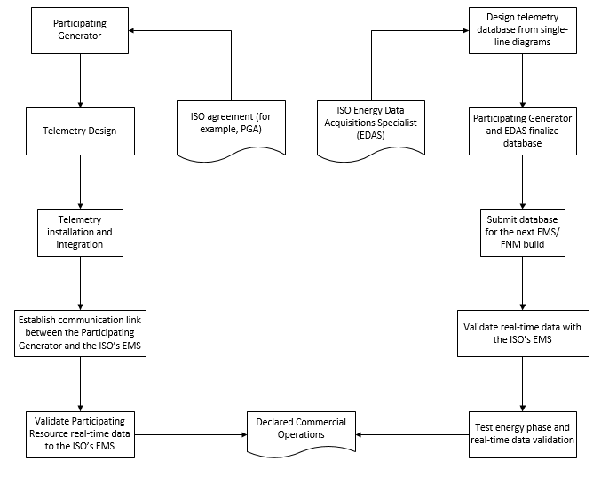

## Flow of Real-Time Data

Exhibit 2-2 illustrates the flow of real-time telemetry data between resources and the ISO’s EMS and from the ISO’s EMS to other ISO systems.

Exhibit 2‑2: Overview of Real-Time Telemetry Data Flow

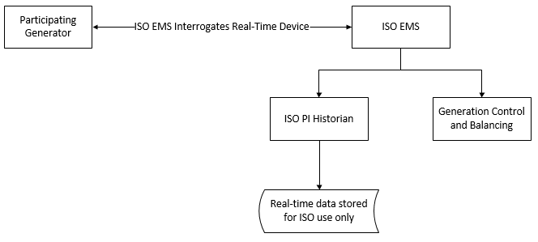

# ISO Responsibilities

This section provides an overview of ISO responsibilities:

* A description of the installation and point-to-point validation process for telemetry facilities;
* A description of the documentation requirements;
* A description of the testing and completion requirements.

## Overview of ISO Responsibilities

Section 7.6.1(d) of the ISO Tariff gives the ISO the authority to direct operations of Generating Units required to control the ISO-Controlled Grid and to maintain reliability by ensuring that sufficient Energy and Ancillary Services are procured through ISO markets. This provision requires each Participating Generator to take, at the direction of the ISO, actions that the ISO determines are necessary to maintain the reliability of the ISO-Controlled Grid. Such actions include (but are not limited to) the provision of communications, telemetry and direct control requirements, including the establishment of a direct communication link from the control room of the Generator Facility to the ISO in a manner that ensures that the ISO will have the ability to direct the operations of the Generator as necessary to maintain the reliability of the ISO-Controlled Grid, except that a Participating Generator will be exempt from these requirements with regard to any Generating Unit with a rated capacity of less than ten (10) MW, unless that Generating Unit is certified by the CAISO to provide Ancillary Services. Appendix Q of the CAISO Tariff describes the telemetry requirements for Eligible Intermittent Resources (EIR) (i.e. solar and wind) of 1MW or larger. Appendix A of the CAISO Tariff under Participating Generator describes the threshold for telemetry being required from 0.5MW or larger (optional) and 1MW or larger..

## Exceptions to Direct Telemetry

A Participating Generator will be exempt from requirements for direct telemetry for any Generating Unit with a rated capacity of less than 10MW, unless that Generating Unit is certified by the ISO to provide Ancillary Services. Appendix Q of the ISO Tariff describes the telemetry requirements for EIRs (solar and wind) of 1MW or larger. Appendix A of the ISO Tariff defines the MW thresholds for a Participating Generator that an EIR resource that is less than 1.0MW and greater than 0.5MW has the option to participate in the ISO markets.

## Direct Telemetry Validation

The ISO has overall responsibility for validating real-time data collected through direct telemetry. The ISO executes this responsibility partially through requirements placed on the Participating Generator (or aggregator), which may include responsibilities satisfied by the Scheduling Coordinator for the resource. This Section 3.2 summarizes the respective certification responsibilities of the ISO and the Participating Generator (or aggregator, or SC, as applicable).

### Overview of Telemetry Installation Validation Process

Exhibit 3-1 illustrates the overall validation process for telemetry facilities.

Exhibit 3‑1: Telemetry Installation Validation Process

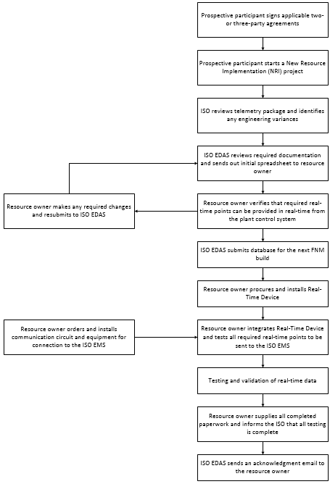

### ISO Certification Responsibilities

The ISO does not accept real-time telemetry data from a resource unless that telemetry data is produced by telemetry facilities that have been validated in accordance with the ISO Tariff and this BPM.

### Documentation Requirements

To initiate the submission process in the scheduled FNM build and for auditing purposes, the prospective Participating Generator must provide the following information through the NRI process:

Schematics

For Generating Units, the prospective Participating Generator must provide all single-line diagrams that depict the Generating Unit connecting to the ISO-Controlled Grid. Such drawings must be dated, bear the current drawing revision number, and show all wiring, connections, and generator equipment devices in the circuits.

Schematics requirements

Detailed station single-line drawings should show:

* How generators, transformers, and aux transformers are connected;
* All breaker and disconnect names, collection busses, showing ISO revenue meter, PT and CT locations;
* How the station is interconnected to the ISO-Controlled Grid.

These schematics must be of the type released for construction and stamped by an Electrical Professional Engineer; that is, the drawings are of a type used for electrical construction permitting purpose with the local permitting agency.

For existing Generator Units (Qualifying Facilities or conversions), all drawings will be as-built drawings depicting ISO revenue metering. The Participating Generator can hand-draw the new ISO revenue meter and any other information covered below for the purpose of fulfilling these requirements. The ISO cannot accept facsimile representations for revised drawings; the submitted revisions must include the original drawings as well as new as-built drawings with all modifications indicated and including an Electrical Professional Engineer stamp.

Other reference information is required but limited to:

Generator data

* MVA rating
* Rated power factor at Pmax
* Nominal terminal voltage
* Reactive power capability curve (limits)
* Terminal voltage control target/range

Transformer Data

* MVA ratings (normal and emergency ratings in different seasons)
* Nominal voltages for all terminal sides
* Impedances (listing voltage base and MVA base where the impedance is calculated)
* LTC data (if applicable):
  + Max TAP and min TAP
  + Voltage control range
  + TAP step size and range
  + Normal TAP position

Generator Tie Data

* Line impedance
* MVA ratings (normal and emergency ratings in different seasons)

Breaker Data

* A breaker that is normally open must be shown in the diagram

Aux Load

* MW and Mvar level

Reactive support devices (shunt capacitor/reactor, SVC, synchronous condenser)

* Rated nominal voltage
* Rated Mvar capacity
* Number of banks and size of each bank if it has multiple banks
* Voltage control target/range
* Database submission process
* FNM build process
* Meter to Point of Delivery (POD), where the POD differs from the meter location

Additional Documentation

* See the NRI process under Resources for all additional document submission required to enter the FNM build.

### ISO Review of Documentation

The Participating Generator must provide all required documentation for an FNM build.

* A Participating Generator who does not deliver required documentation within the FNM build timeline might have to wait until a future FNM build to participate in ISO energy markets according to published timeline dates.
* The Participating Generator has a responsibility to notify an ISO Energy Data Acquisition Specialist within 24 hours of discovery concerning any discrepancies between documentation on file and actual telemetry installation.

# Communications

## Overview of Communications Objectives

The ISO technical operations systems architecture, implemented to carry out resource monitoring and control, incorporates two central systems comprising the ISO’s EMS and operating at each ISO location. The ISO’s EMS has two primary functions:

* Provides AGC and operator dispatch support for monitoring and control of each Participating Generator;
* Provides for the monitoring of the transmission system within the ISO Balancing Authority Area.

In order for the ISO to comply with its responsibilities, the Participating Generator is required to install a DNP3-capable Real-Time Device (as described in this BPM) that meets ISO functionality, reliability, and security objectives. The Real-Time Device establishes a real-time data interface between the Participating Generator’s local control systems and the ISO’s EMS. The Participating Generator can validate its own control system to interface with the ISO’s EMS; see the Real-Time Device Validation Procedure under References.

## Choice of Connection Methods

The ISO recognizes that Participating Generators require choice in the technical methods available to them to connect to the ISO in order to provide direct telemetry in support of ISO reliability and security objectives.

Historically, the ISO envisioned and realized an ECN as a SCADA communications network for the Western Interconnection. Over time, the ISO has continued to mature the ECN as a reliable digital communications network to support telemetry directly to generators as well as to revenue meters and between SCADA control centers.

The ECN supports the reliability and availability of critical grid operations and mitigates risks associated with public networks by providing more bandwidth assurance and higher service levels. The ISO has recognized that the ECN natively does not assure protection against unauthorized access to or modification of customer data; the ISO therefore provides an option for encrypting and digitally signing communications between the ISO EMS and Real-Time Devices at Participating Generators in the form of SSL/TLS and X.509 digital certificates. The combination of authenticating and digitally signing communications for direct telemetry has provided a kind of non-reputability for instructions that the ISO sends to generators – assurance on both sides in the delivery and receipt of critical communications such as AGC.

Over time, the reliability of the public Internet has improved but cyber threat to public networks has increased. Concurrently, the operational cost of leasing use of semi-private networks such as the ECN has increased relative to the cost of employing the various software-defined security overlays now available on public networks for connecting remote locations. Driven by Cloud computing, public networks continue to evolve to support secure and cost-efficient interconnection. The ISO continues to adapt to provide increasingly more cost-effective communications options that reduce barriers to participating in ISO markets.

Telecommunication options continue to evolve rapidly to meet customer demand and competitive constraints. The same companies that support the retail Internet support the increasingly digitally interconnected North American reliability and energy infrastructure. Digital security continues to evolve to meet higher levels of risk and threat; consequently, communications options available to Participating Generators continue to evolve to include network overlays that assure the confidentiality, integrity, and availability of the information required to secure the market-driven grid.

In 2016, the FERC approved a new type of ISO market participant called a Distributed Energy Resource (DER) Aggregate (DERA). The aggregation point is a market resource. Participants in the market asked the ISO to evaluate new options for securing DERA telemetry in order to reduce barriers to entering ISO markets. Specifically, prospective participants sought to use their existing Internet broadband, instead of the ECN, to the ISO; these participants also requested an alternative to participant-managed PKI. The ISO has responded by adding two communications options secured on the public Internet, one of which continues to require use of digital certificates.

## Communication Context Diagram

This section describes the main communication options available to Participating Generators in the ISO Balancing Authority Area. Participating Generators must choose whether to connect over the ECN or over the public Internet to receive DNP3 polls from the ISO’s EMS. For non-ECN connections, Participating Generators can choose between an IPsec connection provided by AT&T, Internet Service Provider with a static IP range, or a software-defined solution provided by Dispersive Technologies.

Exhibit 4-1 depicts the three communication options available to Participating Generators. There is no attempt to depict a complete communication diagram with all network equipment and servers; the purpose of the diagram is only to depict context for use of the ECN or the public Internet as well as where participant-managed digital certificates are required. The four communications options are:

* The Participating Generator leases a T1 connection to the ECN from AT&T and purchases a router with a T1 interface; this option requires an SSL/TLS digital certificate and the participant can optionally contract with AT&T to have the router managed and maintained.
* AT&T installs an ANIRA IPsec VPN gateway at the Participating Generator’s site to backhaul data over the public Internet to the ECN; the Participating Generator does not need a T1 connection to the ECN but does need to provide a broadband connection and manage an SSL/TLS digital certificate.
* Dispersive Technologies installs a Dispersive™ CISDN gateway; the Participating Generator does not need a T1 connection to the ECN, does not need to manage a digital certificate, but does need to provide a broadband connection.
* The Participating Generator leases an Internet Service Provider (ISP) connection to the Internet from any ISP and purchases a router. This option requires an SSL/TLS digital certificate and the participant can optionally contract with the ISP to have the connection managed and maintained.

Exhibit 4-1: Context Diagram for Communications Options for Direct Telemetry

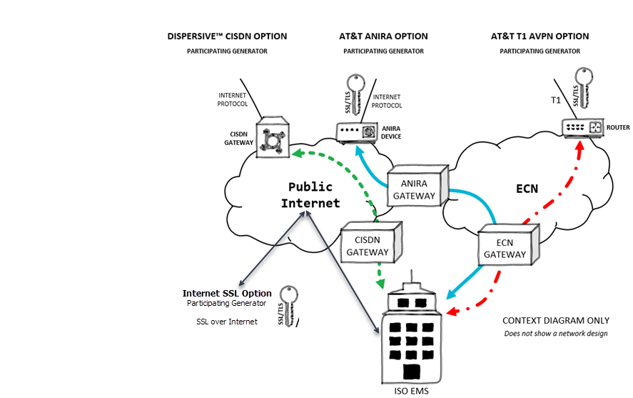

## Main Communication Options

Table 4-2 shows the main requirements for each connectivity/security requirement as Yes (required) or No (not required).

Table 4-2: Main Requirements for Each Communication Option for Direct Telemetry

|  |  |  |  |  |
| --- | --- | --- | --- | --- |
| ***Connectivity/Security Requirement*** | ***AT&T Leased T1 Line*** | **AT&T ANIRA IPsec VPN** | **Internet Service Provider** | **Dispersive™ CISDN** |
| Participating Generator Leases ECN Connection | Yes | No | No | No |
| Participating Generator Provides Broadband Internet Connection | No | Yes | Yes | Yes |
| Participating Generator Installs an ISO-Issued Digital Certificate | Yes | Yes | Yes | No |

## Detailed Communication Options

Table 4-3 provides a detailed comparison of communications options.

Table 4-3: Detailed Comparison of Communication Options for Direct Telemetry

| ***Connectivity Option*** | **AT&T Leased T1 Line** | **AT&T ANIRA IPsec VPN** | **Internet Service Provider** | **DispersiveTM CISDN** |
| --- | --- | --- | --- | --- |
| *Connectivity* | Participant leases a T1 connection to the ECN and provides a router with a T1 interface; the participant’s site must be protected by a firewall | AT&T installs an ANIRA IPsec VPN gateway at the participant’s site to backhaul data over the public Internet to the ECN; the participant provides a broadband connection | ISP provides gateway at the participant’s site or control room to backhaul data over the public Internet; the participant provides a broadband connection | The participant provides a broadband connection; no T1 or ECN backhaul required |
| *Encryption* | Data encryption provided from the participant’s SSL/TLS gateway to the ISO using a participant-managed, ISO-provided, periodically expiring X.509 digital certificate | Data encryption provided from the participant’s SSL/TLS gateway to the ISO using a participant-managed, ISO-provided, periodically expiring X.509 digital certificate; network encryption over the public Internet to the participant’s ECN router provided by the ANIRA gateway | Data encryption provided from the participant’s SSL/TLS gateway to the ISO using a participant-managed, ISO-provided, periodically expiring X.509 digital certificate | Data encryption provided from the participant’s Dispersive™ CISDN gateway to the ISO without requirement for a participant-managed X.509 digital certificate |
| *Time to Provision* | Allow three months | Allow three months | ISP order processing time | Allow 30 days |
| *Maintenance of Digital Certificates* | The participant manages periodic renewal of an ISO-provided X.509 digital certificate | The participant manages periodic renewal of an ISO-provided X.509 digital certificate | The participant manages periodic renewal of an ISO-provided X.509 digital certificate | None |
| *Router Maintenance* | The participant can optionally contract with AT&T to manage the ECN router | Maintenance of the ANIRA gateway is included in the monthly service cost | The participant can optionally contract with ISP for maintenance | Maintenance of the Dispersive™ CISDN gateway is included in the monthly service cost |
| *Periodic Costs* | Monthly cost for T1 service; participant can manage the ECN router or pay AT&T to manage it; possible monthly service costs for a branded Real-Time Device | Monthly cost for ANIRA service; possible monthly service costs for a branded Real-Time Device | Monthly cost for managed ISP service | Monthly cost for managed Dispersive™ CISDN service |
| *Additional Costs* | One-time costs for a Cisco router, a firewall, and either a participant-managed SSL/TLS gateway or a branded Real-Time Device (with possible associated monthly service costs) | A one-time cost for either a participant-managed SSL/TLS gateway or a branded Real-Time Device (with possible associated monthly service costs) | A one-time cost for ISP hardware | A one-time cost for a Dispersive™ CISDN hardware security gateway |
| *Ruggedized Gateway Available* | Yes/No | Yes/No | Yes/No | Yes |

## Ruggedized Gateway Available

The ruggedized construction option available for the Dispersive™ CISDN and other types of connections in fore mentioned option refers to resistance to shock and vibration as well as a wide range of operating temperatures. The following suggested ruggedized parameters can be found in many network gateways and it is the option of the interconnection customer to determine the need for ruggedized equipment. The ISO does not mandate ruggedized equipment to be installed.

* Temperature range -13°F to 158°F (-25°C to 70°C);
* Resistance to shock (50 Grms);
* Resistance to vibration (5 Grms);
* Protection against overcurrent, overvoltage, and electrostatic discharge.

## ISO Security for Direct Telemetry

### Data Confidentiality

Information transmitted via the Real-Time Device from a Participating Generator to the ISO’s EMS will be treated by the ISO as the Participating Generator’s confidential information in accordance with the ISO Tariff.

### Network Security Principles and Best Practices

The ISO documents the following principles and best practices as a guideline for Participating Generators and in the spirit of NERC CIP compliance to which they might already be subject.

* Information is a critical asset for the ISO.
* Protecting information assets from unauthorized or incorrect use or modification, destruction, or disclosure requires planning, teamwork, cooperation, and vigilance.
* Network access must be provisioned and maintained in such a way that only authorized users are given access to information and only with the tools required for the job.
* ECN Provider Edge Routers must not peer with Customer Edge Routers managed by Participating Generators.
  + This means that AT&T routers must not share ECN routes with ECN routers managed by Participating Generators.
  + The practical meaning of this best practice is to minimize risk to other Participating Generators on the ECN at large.
* The ECN must not bridge to the public Internet and vice versa.
  + The practical meaning of this best practice is that a device at the Participating Generator's site must not be dual homed, with one network interface connected to the ECN and the other network interface connected to the public Internet.
  + The reason for this best practice is that a device compromised by malware from a less trusted network can convey the destructive payload of that malware to more trusted network by means of the physical device that bridges the two networks.
  + A firewall that protects the device can securely multi-home the networks that it controls.
* The Participating Generator owns security at the entities facility where the ECN is installed .
  + Perimeter routers connecting the Participating Generator to the ECN must use ACLs to restrict both ingress (inbound) and egress (outbound) traffic.
  + Ingress ACLs on ECN routers must be designed to allow only trusted devices and protocols.
  + Egress ACLs must be designed to allow only traffic from assigned local IP addresses.
* Participating Generators are encouraged to review security best practices described in NIST SP 800-82 (see References), particularly in the section called Network Segmentation under ICS Security Architecture.

### Communication Security Characteristics

Communication of direct telemetry to the ISO’s EMS must be secure. All communication options are acceptable up to 1200MW per connection and 25 aggregated resources per Real-Time Device. Beyond those limits, the ISO requires a second network connection.

Security has four main components:

* *Availability* – Refers to reliability and uptime.
* *Data Integrity* – Refers to protection against unauthorized data modification.
* *Data Confidentiality* – Refers to protection against unauthorized access to data.
* *Authenticity* – Refers to the authentication and authorization of business transactions (one example of a business transaction is a SCADA setpoint instruction).

The ECN provides a high level of availability, reliability, and uptime, but, without additional security overlays, it does not provide integrity, confidentiality, or authenticity.

As Cloud architecture evolves to support higher levels of availability and reliability, VPN technologies are adapting to provide equivalent uptime over software-defined networks (SDN). Advantages of SDN include real-time response to network congestion or compromise to assure packet flow and enhanced capabilities to aggregate multiple types of broadband links to provide link failover as well as higher throughput. The Dispersive™ CISDN communication option described in this BPM is an example of SDN extended to the Wide-Area Network (SD-WAN) and particularly suitable for SCADA systems.

#### Data Integrity

Protecting the integrity of SCADA communications against network eavesdropping and MitM attacks helps assure the health of an economy that increasingly depends on highly reliable digital delivery of electricity through markets. This means that cybersecurity protections mitigate the threat of unauthorized modification or interception of SCADA instructions between the authorized sender (the ISO’s EMS) and the authorized receiver (the Participating Generator’s Real-Time Device). The electric grid cannot be reliable without integrity assurance.

#### Data Confidentiality

Data confidentiality is typically assured by data encryption, an algorithmic process for rendering data undecipherable to users or identities who are not authorized to decrypt it. Confidentiality is broadly important for all data owned by Participating Generators (as protected by the ISO’s Tariff), but it is particularly important for data from the revenue meters through which grid reliability is coupled with the mechanisms of deregulated markets. The ISO enforces data encryption either through SSL/TLS digital certificates managed in software applications by Participating Generators or directly through network automation as part of a managed service provided to Participating Generators.

#### Authenticity

Authenticity requires some means of proving identity, which could be a machine identity or a human identity and could refer either to the sender or the receiver of a business transaction. In the context of this BPM, identity refers either to the ISO’s EMS (sender) or the Participating Generator’s Real-Time Device (receiver).

The ISO provides two options for assuring the authenticity of business transactions:

* *X.509 digital certificates for sender and receiver form a mutually authenticated and encrypted SSL/TLS network transport channel for SCADA instructions.* ISO-issued participant-managed digital certificates provide this option either over leased T1 lines connected to the ECN, ISP or through the managed ANIRA service.
* *Automated just-in-time data encryption authorizes pre-authenticated network identifies to complete a transaction.* The quality of “just in time” refers to encryption keys that change periodically to defeat persistent network eavesdropping. The Dispersive™ CISDN managed service provides this option without requirement for the Participating Generators to connect to the ECN or to maintain X.509 digital certificates.

A combination of authenticity and integrity can provide a level of digital assurance that information has arrived at its intended destination. The relevance of this for direct telemetry is assurance, in the form of non-reputability, that a Participating Generator received an instruction from the ISO’s EMS.

### Communication Security Protocols

Real-Time Devices may support a number of standard available plant interface protocols. The Participating Generator has the option of designing its own integration solution for the Real-Time Device or hiring an integrator of its choice. The encryption options below can be easily achieved by either approach. Participating Generators should contact an ISO Energy Data Acquisition Specialist for consultation before designing or installing a Real-Time Device.

The protocol required between the Participating Generator Real-Time Device and the ISO’s EMS is DNP3 with one of the following encryption options:

* **SSL/TLS**
  + This option requires that the Participating Generator manage an X.509 digital certificate that is issued by the ISO and periodically requires renewal.
  + This option requires network transport provisioned by AT&T; the AT&T connection can be either:
    - A broadband ISP connection secured by an ANIRA IPsec VPN gateway in line with a Participating Generator’s existing broadband link; or
    - A broadband ISP connection gateway in line with a Participating Generator’s existing broadband link; or
    - An ECN connection with T1 line provisioned by AT&T.
  + SSL/TLS provides encryption over the ECN.
* **Dispersive™ CISDN**
  + Dispersive™ CISDN is a security overlay on the public Internet.
  + With this option, the Participating Generator does not need to manage a digital certificate.
  + This option does not require an ECN connection or AT&T provisioning, but the Participating Generator must provide a broadband link.
  + Dispersive™ CISDN provides encryption over the public Internet.

### Communication and ECN Agreements

DNP3 communications from a Real-Time Device to the ISO must be encrypted. There are two ways to provide encryption: 1) SSL/TLS digital certificates issued by the ISO and managed by the Participating Generator; 2) automated encryption provided by Dispersive™ CISDN. PKI and ECN agreements govern encryption using SSL/TLS over the ECN. PKI agreements also apply to connections of a Real-Time Device over the public Internet. Participating Generators can also meet the encryption requirements using the Dispersive™ CISDN communications options described in sections following. This BPM requires adherence to the following security agreements (see References).

* For AT&T-provisioned connections (ECN, ISP, or ANIRA), the Participating Generator must sign the Certificate Practice Statement for Basic Assurance Certification Authority.
* For all connections, the Participating Generator must sign the Network Connectivity Security Requirements and Agreement.
* The Participating Generator is required to follow policy described in the Information Security Requirements for the Energy Communication Network (ECN).
* Form submission with the proper filename convention is a precursor to opening communication from the ISO’s EMS. See New Resource Implementation Contact in References for submission e-mail address.

### Connected Entity Service Guides

For connecting to the ISO EMS, Participating Generators (as Connected Entities) can choose among three options: AT&T, ISP, and Dispersive Technologies option.

* The ECN connection requires a T1 circuit provisioned by AT&T.
* For connecting to the ISO EMS over the public Internet, Participating Generators have three options:
  + AT&T ANIRA
  + ISP
  + Dispersive™ CISDN
* Aconnection option above is required for connecting a Real-Time Device to the ISO EMS.
* Use of ISO-issued digital certificates is required except in for the Dispersive™ CISDN option.

This BPM references service guides for both AT&T options and the Dispersive™ CISDN option (see References).

* *AT&T Connected Entity Service Guide*
  + A direct ECN connection requires an AT&T-provisioned T1 circuit.
  + The AT&T ANIRA connection uses a Participating Generator’s existing Ethernet or cellular IP broadband link, obtained through the local ISP, to connect to the ECN; there is no requirement for a T1 circuit.
  + Both options require use of an ISO-provisioned SSL/TLS digital certificate to establish an encrypted communication channel over the ECN, which natively has no encryption.
    - The ANIRA connection is encrypted between the Participating Generator and the ECN but not over the ECN to the ISO EMS; SSL/TLS provides encryption over the ECN.
    - The T1 connection is encrypted between the Participating Generator and the ISO EMS over the ECN using SSL/TLS.
* *Dispersive™ CISDN Connected Entity Service Guide*
  + The Dispersive™ CISDN connection uses a Participating Generator’s existing Ethernet, DSL, cellular IP, satellite IP, or wireless link obtained through the local ISP.
  + This option can aggregate multiple inks into a single logical circuit for redundancy and resilience.
  + The Dispersive™ CISDN option does not require ECN or ISO-provisioned, customer-managed digital certificates.
* *ISP Connected Entities please refer to their service guide*

## Reliability

### Redundant Circuits

The Participating Generator may optionally implement a diversely routed secondary communications circuit. The ISO recommends using redundant circuits when feasible. The procurement of redundant circuits and paths is the Participating Generator’s responsibility and the redundancy must be managed by the connection service provider.

### Data Validation

All telemetry data reported from the Real-Time Device must be within +/-2% of the true value. The ISO or its designee may inspect the Participating Generator’s Real-Time Device and related facilities to verify the accuracy and validity of all ISO telemetry. All data telemetry provided through the Participating Generator’s Real-Time Device must be tested by the Participating Generator or Participating Generator’s representative for accuracy and validity on a periodic basis as necessary to ensure that accuracy requirements are maintained. The best practice is to test all resource data annually for accuracy.

### Voice Communications

Each Participating Generator in the ISO’s market model must be able to establish normal voice communication over a dedicated voice communications circuit from the Participating Generator local control center that has immediate remote and manual control of the Generating Unit(s).

A dedicated voice communication circuit is one that is available at all times for communication purposes between the ISO’s dispatchers and the Generating Unit’s local control center.

### Communications During Telemetry Failure

In the case of telemetry failure, a Participating Generator that provides real-time data is responsible for manually communicating generation values to the ISO on a 24x7 basis until normal telemetry is restored. See section 8.4 for additional details on this subject.

# Operational Telemetry Requirements

## Unit Telemetry Visibility

Each resource participating in the ISO’s Ancillary Services markets or any Eligible Intermittent Resource or any resource providing Energy with a capacity of 10MW or greater that is not exempt pursuant to the ISO Tariff must provide telemetry data according to the point matrix specified in Section 7 of this document and pursuant to ISO Tariff Section 7.6.1(d).

## Performance Monitoring

### Direct Telemetry Timing Requirements

Exhibit 5-1 shows the performance and timing requirements for a Generating Unit connected to the ISO EMS.

* A Participating Generator must be able to ***accept*** and begin processing direct digital control (DDC) signals (Set Points) within the ISO time standard (two-second maximum from ISO’s EMS to output of the Real-Time Device). The two-second maximum includes any Generator or third-party communication equipment located between the ISO and the Participating Generator.
* A Participating Generator must be able to ***send*** data to the ISO within the ISO time standard (two seconds from the input of the Real-Time Device to the ISO EMS).
* The plant controller must receive the signal from the Real-Time Device within the ISO time standard (an additional two seconds from output of the Real-Time Device to plant controller).
* The time standards also apply in the return direction, resulting in a total maximum of eight seconds, round trip, for the signal to travel from the ISO EMS to the plant controller and back.
* The timing requirements from the ISO EMS to the plant control system (for example, DCS, RTU) through the use of non-ISO communication equipment must meet the ISO two-second time standard in one direction.
* The timing requirements from the plant control system back to the ISO EMS through the use of non-ISO communication equipment must meet the ISO two-second time standard in the return direction.

Exhibit 5-1: Timing of Telemetered Real-Time Data for Generators Providing Ancillary Services or Energy Only through a Real-Time Device

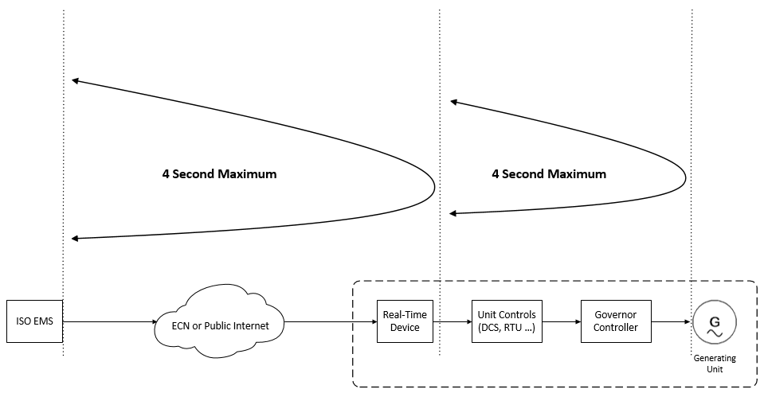

### PDR Timing Requirements

The provisions of the section above apply to PDR telemetry, except that the resource telemetry requirement may be expanded to either one (1) minute when participating in the Day-Ahead, Real-Time, and Non-Spinning Reserve markets or five (5) minutes when participating in the Day-Ahead or Real-Time markets. The election for one (1) minute or five (5) minutes is applied to all locations underlying the PDR. The per-location readings that make up the resource-level telemetry will be time-aligned within any PDR resource to within a +/-30 second time accuracy compared to a resource-specific synchronization time. If a location’s telemetry source drifts outside of this band the Participating Generator is responsible for synchronizing the telemetry source. In all cases, the resource-level telemetry points must be available within Real-Time Device for the ISO’s 4-second poll with no more than a 1-minute latency. Exhibit 5-2 highlights this timing in the 5-minute case.

Exhibit 5-2: PDR Timing, 5- Minute Case

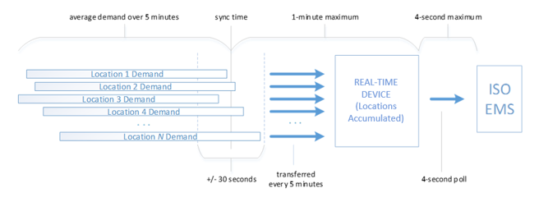

The timing referenced this section also applies to PDR participating in the Spinning Reserve Market.

Real-Time Devices providing telemetry for PDRs must provide valid data points only during the time that the PDR is in a dispatchable state, including one hour leading up to and one hour after that state. Dispatchable is defined as any time the resource has the potential for energy dispatch, specifically during day-ahead award hours and real-time energy bids*.*

### PDR Reading Requirements

The provisions in this document shall apply to PDR telemetry, except that all references to “real-time updated value and not averaged over time” should be taken as “real-time updated value or average reading over the PDR timing interval” for PDRs.

## ISO Real-Time Communication Technical Design Options

With the recharacterization of a RIG as any Real-Time Device that meets the security and operational objectives for direct telemetry, the ISO now supports both branded (turn-key) and non-branded (build-your-own) technical designs. Hybrid solutions are also possible. Contact an ISO Energy Data Acquisition Specialist for consultation using the contact information in the References section of this BPM.

The ISO is continually looking for options that will allow Participating Generators to connect to the ISO’s EMS in a cost-effective and secure manner. A Real-Time Device can be software running on a Plant Control System or a combination of software optionally hardware on a separate device. Its function as an interface to the ISO’s EMS can be either logically or physically segmented at the Participating Generator’s site. This section describes multiple secure options that will allow the Participating Generator’s control system to connect to the ISO’s EMS by means of a Real-Time Device.

The ISO’s EMS controls and monitors resource sites from two physical locations with two connections in simultaneous operation. This exchange of data is performed using Real-Time Devices either over the ECN or using a Participating Generator’s existing broadband link.

### Functional Components of Real-Time Communication Options

The functional components of real-time communication options, without regard to specific implementation, are as follows.

* **Plant Systems:** Each plant providing Ancillary Services or Energy has a control system that obtains telemetry from Generating Units. Various measured values must be available from the Plant Control System as described in this BPM. The Plant Control System constitutes the source of the telemetry necessary to comply with the ISO’s standards, pursuant to ISO Tariff Section 7.6.1(d).
* **Plant Interface Protocol:** The interface between the Real-Time Device and the plant control system can be any protocol convenient to the control system, according to the relationship between the supplier and the Participating Generator.
* **SSL/TLS Encryption Layer:** With SSL/TLS, the ISO’s EMS real-time IP DNP3 poll converts to TCP in-the-clear or serial DNP3 protocol at the resource control system. The SSL/TLS capability may reside on the Plant Control System or on separate hardware.
* **Dispersive™ CISDN:** With this option, an alternative to the SSL/TLS, encryption layer, the real-time DNP3-over-TCP/IP poll from the ISO’s EMS is encoded to traverse a resilient software-define network. There is no requirement to manage digital certificates at the plant. There is no requirement for ECN. Dispersive™ CISDN can reside on hardware separate from the Plant Control System or as software on a Real-Time Device. For resiliency, Dispersive™ CISDN supports multiple broadband links (Ethernet, DSL, cellular IP, satellite IP, or wireless) and aggregation of those links.
* **Exemption from Simultaneous Connection:** The ISO may grant an exemption from the requirement to establish two simultaneous connections for an intermittent resource with a capacity less than 10MW. For resources with a capacity of 10MW or greater, both the SSL/TLS and Dispersive™ CISDN options must meet the ISO standard for simultaneous connections.
* **ECN Connection:** The Energy Communications Network (ECN) is a semi-private AT&T MPLS communications network option for telemetry from the Real-Time Device to the ISO’s EMS. AT&T provisions access to the ECN. The ECN natively has no encryption. ECN connectivity is not required for the Dispersive™ CISDN option. AT&T can provision ECN connectivity either as a T1 circuit with a customer-provisioned router or as an ANIRA IPsec VPN tunnel to the ECN. The ANIRA gateway has Ethernet and cellular IP capability.
* **Internet Connection:** The connection option for the public Internet is for real-time data through an ISP for the purpose of telemetry in the same manner as the ECN. The ANIRA and Dispersive™ CISDN options support this method.
* **Securing DNP3 over TCP/IP:** The DNP3 protocol communicated over the TCP/IP transport must be secured. The ISO’s EMS does not use the DNP3 SA (Secure Authentication) extension but achieves the same, plus encryption, using one of the following two methods:
  + SSL/TLS with a customer-managed and periodically expiring digital certificate provisioned by the ISO
  + Dispersive™ CISDN managed security service
* **ISO EMS:** All telemetry arrives at the ISO’s EMS encrypted over TCP/IP via either the ECN or an ISP network.

### Transport Options

The ISO supports three transport options for direct telemetry:

1. ECN with T1 leased circuit.
2. Public Internet with ANIRA IPsec VPN backhaul to ECN.
3. Public Internet with Dispersive™ CISDN.

Option one requires the Participating Generator to lease a T1 circuit from AT&T to connect to the ECN. This option does not use the public Internet. The Participating Generator must manage an ISO-issued digital certificate to secure the communication link.

Option two requires the Participating Generator to provide a broadband circuit and to contract with AT&T to install an ANIRA IPsec VPN gateway to connect to the ECN. The Participating Generator does not need to lease a T1 circuit. The Participating Generator must manage an ISO-issued digital certificate to secure the communication link.

Option three requires the Participating Generator to provide a broadband circuit and to contract with Dispersive Technologies to install CISDN. The Participating Generator does not need to lease a T1 circuit and does not need to manage an ISO-issued digital certificate to secure the communication link.

### Transport Conceptual Diagrams

The following diagrams conceptually depict each of the three transport options described above. These diagrams do not depict the requirement for a Real-Time Device to receive two polls simultaneously from each ISO EMS.

#### ECN with T1 leased circuit.

In Exhibit 5-3, Customer Edge refers to a router with a T1 interface that a Participating Generator must purchase to connect to the ECN through the AT&T Provider Edge router. The Participating Generator may optionally contract with AT&T for management of the Customer Edge router. The key symbol labeled with SSL/TLS shows use of an ISO-issued digital certificate that the Participating Generator must manage on the Real-Time Device.

Exhibit 5-3: Transport Option – ECN with T1 Leased Circuit

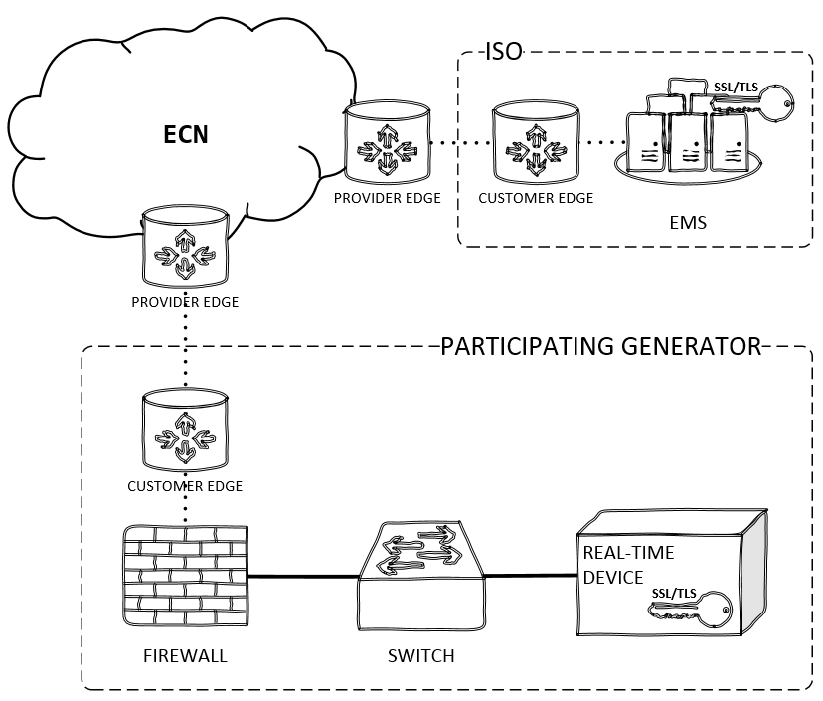

#### Public Internet with ANIRA IPsec VPN backhaul to ECN.

Exhibit 5-4 depicts the IPsec tunnel between the Participating Generator’s ANIRA gateway and the ANIRA gateway (or concentrator) on the ECN edge. The Participating Generator provides a broadband connection that serves as the site’s gateway for the IPsec tunnel over the public Internet between the generator site and the ECN. The key symbol labeled with SSL/TLS shows use of an ISO-issued digital certificate that the Participating Generator must manage on the Real-Time Device. ANIRA supports Ethernet and cellular IP connections.

Exhibit 5-4: Transport Option – Public Internet with ANIRA IPsec VPN Backhaul to ECN

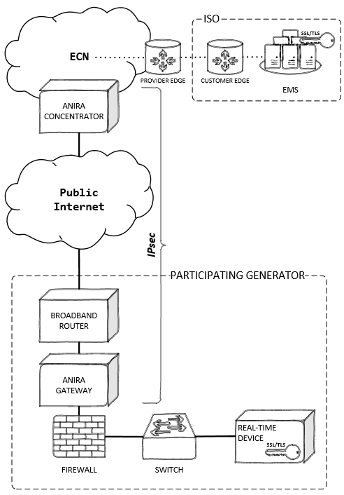

#### Public Internet with Dispersive™ CISDN.

Exhibit 5-5 depicts use of the Critical Infrastructure Software-Defined Network (CISDN) maintained by Dispersive Technologies to transport encrypted packets between the ISO EMS and the Participating Generator’s Real-Time Device without requirement for a participant-managed ISO-issued digital certificate and without. For resiliency, CISDN supports aggregation of multiple broadband links (Ethernet, DSL, cellular IP, satellite IP, or wireless).

A Dispersive™ Edge Gateway at the Participating Generator’s site can take the form of software or ruggedized hardware (see Ruggedized Gateway Available in this BPM for characteristics of the ruggedized hardware). The Dispersive™ CISDN hardware gateway, provided by Dispersive Technologies, is an additional device at the Participating Generator’s site. The Dispersive™ CISDN software gateway is installed either on the Participating Generator’s own hardware, separate from the Real-Time Device, or on the Real-Time Device itself.

Exhibit 5-5: Transport Option – Public Internet with Dispersive™ CISDN

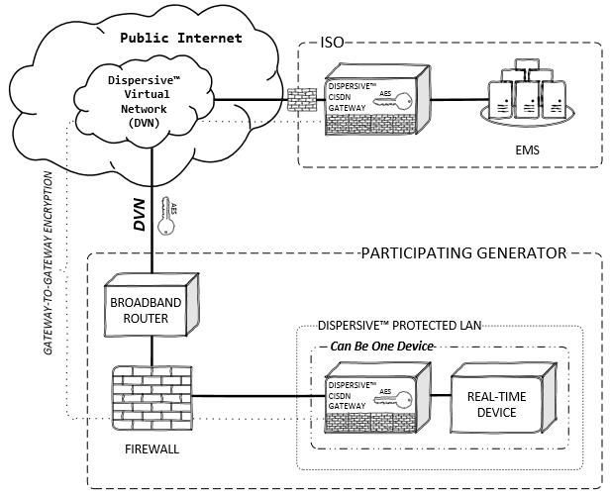

The Dispersive™ CISDN option uses an advanced Cloud controller to provide immunity to data interception through use of deflects or waypoints to splinter encrypted DNP3 protocol messages at the site and reliably deliver and reassemble those messages at the ISO using optimized checksumming algorithms. Access to the Dispersive network is strictly controlled based on a zero-trust model.

The CISDN service option available to Participating Generator’s is called *Fully Managed SaaS with Field Gateway IPP-1000*. For more information on CISDN, see *Establishing Dispersive™ CISDN Connectivity with the ISO* under References.

* With the CISDN transport option, there is no requirement for the Participating Generator to lease a T1 circuit from AT&T.
* This diagram uses a “cloud within a cloud” concept to illustrate use of the Dispersive™ Virtual Network (DVN) to splinter packet pieces across a managed network of waypoints between the CISDN gateways before reassembling the data at the receiving end.
* Transport is optimized using reliable UDP algorithms between the CISDN gateways with no effect on the DNP3 over TCP required by the ISO’s EMS and the Participating Generator’s Real-Time Device.
* The key symbol with AES refers to encryption of packet data between the CISDN gateways using the Advanced Encryption Standard.
* The Dispersive™ CISDN gateway can be physical hardware that protects the Real-Time Device or can be software installed on the Real-Time Device.
* The Dispersive™ Protected LAN shown in the diagram could be a zone on the site’s edge firewall; the general concept is that CISDN occupies a “LAN within a LAN” at the Participating Generator’s site, with implementation details left to the Participating Generator to determine.
* The firewall symbol embedded on the CISDN gateway illustrates use of an integrated firewall to block non-CISDN traffic and enforce allowed communication only between the ISO and trusted CISDN sites. Allowed CISDN connections are enforced at a peer-to-peer level in the DVN using only defined protocols and ports.

Exhibit 5-6 depicts the Dispersive™ CISDN option in full context with the plant’s physical boundary and CISDN Cloud components. The Dispersive™ Edge Gateway and the Real-Time Device as physically separate devices; these functions, however, can exist on a single physical device. The Real-Time Device at the plant must communicate DNP3 protocol over TCP port 20000. The ISO may grant an exemption from the requirement to establish two simultaneous connections for an intermittent resource with a capacity less than 10MW. For resources with a capacity of 10MW or greater, the Dispersive™ CISDN options must meet the ISO standard for simultaneous connections.

Exhibit 5-6: Dispersive™ CISDN Hardware Option

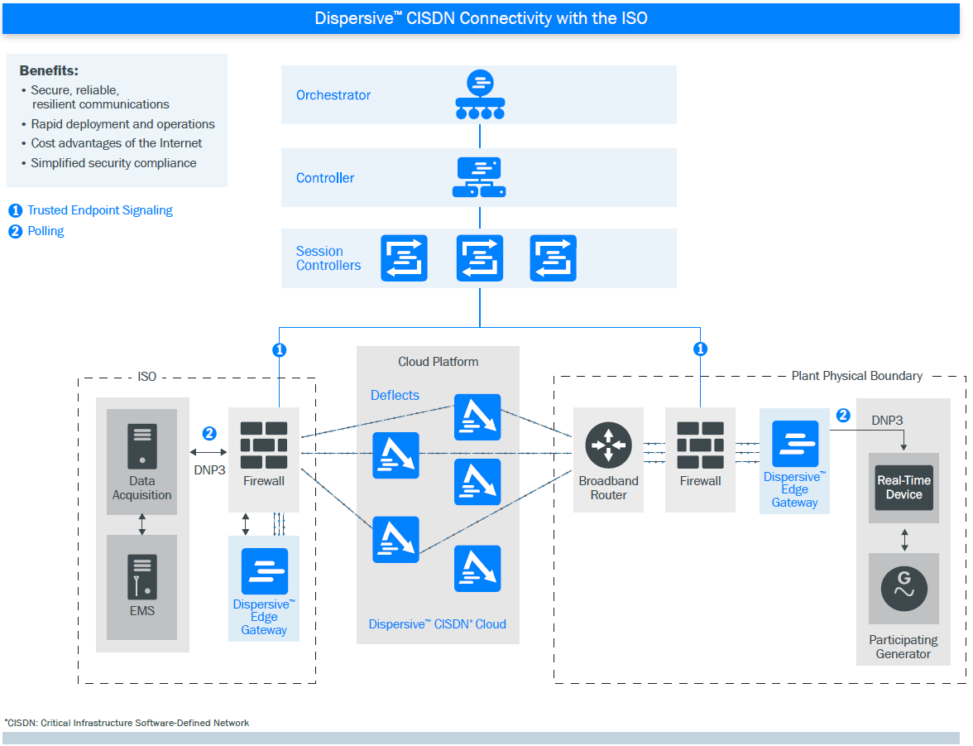

### Direct Telemetry Hardware Options

The purpose of this section is to illustrate hardware options for direct telemetry. Participating Generators have the option to build their own Real-Time Devices to interface to plant devices. Unless using the ANIRA transport option, Participating Generators also have the option to install or build their own security devices, as long as those devices meet ISO security objectives. There are three security options: SSL/TLS, IPsec plus SSL/TLS, and Dispersive™ CISDN.

#### Plant Control System Hardware Option

In this option, the Plant Control System functions as the Real-Time Device. The software can reside on the Plant Control System. The device performs either an SSL/TLS connection or a CISDN connection for DNP3 data over TCP.

The ISO’s EMS communications with the Plant Control System using the DNP3 protocol. For this option, the Plant Control System must have an outstation DNP3 protocol driver. Real-time data that comes from meters and other plant devices must reside on the Plant Control System. The security gateway handles either an SSL/TLS or CISDN connection.

This option must pass security validations as conducted during the ISO’s NRI process. The ISO does not certify Real-Time Devices; Participating Generators may use any Real-Time Device that the ISO has tested for all required functions.

Exhibit 5-7 shows the data flow for this option. A commodity network load balancer may provide the SSL/TLS gateway.

Exhibit 5-7: Plant Control System Hardware Option

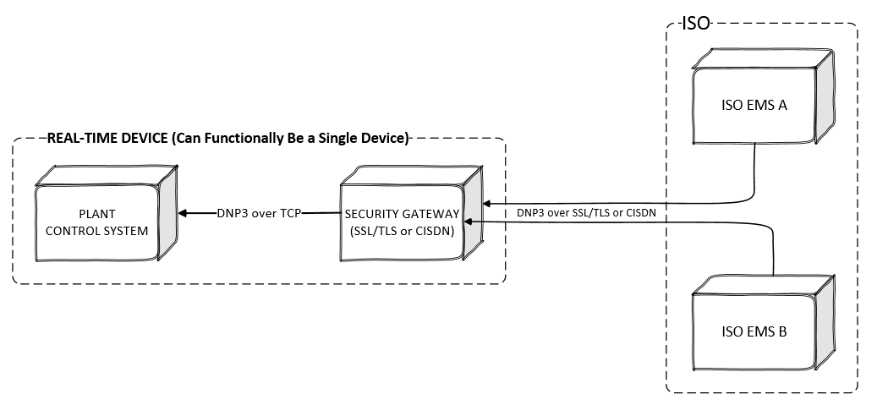

Exhibit 5-8 identifies, by number, the aspects of a serial or TCP clear-text solution. The diagram represents a high-level overview of the perceived functionality of the solution. It is provided for illustration purposes only. The interfaces, envisioned through an abstraction of the internal functionality of the hardware device, are numbered and described below.

Exhibit 5-8: Plant Control System Hardware Option Functional Diagram

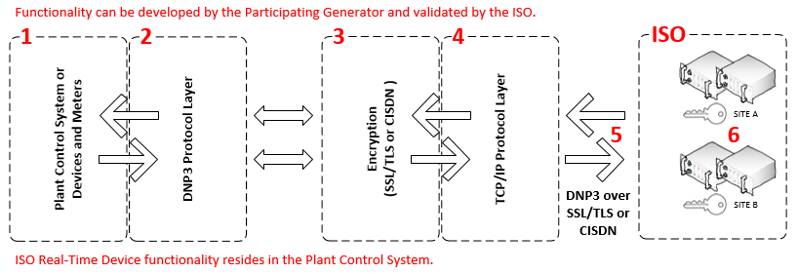

1. **Plant Control System**: Must perform all Real-Time Device functionality described in this document.

2. **DNP3 Output Interface Protocol Layer**: The Plant Control System must communicate with the DNP3 subordinate protocol and support the objects and variations described in this document.

3. **Encryption Layer**: This layer will be an implementation of SSL/TLS using ISO-issued digital certificates or an implementation of Dispersive™ CISDN.

4. **TCP/IP Output Interface Layer**: The serial to IP device acts as the TCP server/connection. Once the serial to IP device has requested and established the TCP connection, the encrypted DNP3 compatible data stream passes through a TCP/IP connection over a TCP/IP network.

5. **DNP3 over TCP/IP over SSL/TLS or DNP3 over CISDN**: Secure DNP3 data over TCP/IP is achieved when the encrypted DNP3 compatible data stream is transported onto the TCP/IP network. Encryption is provided by SSL/TLS or Dispersive™ CISDN.

6. **ISO Multi-Porting Capability**: The security device must have one IP address with the ability to communicate with two simultaneous TCP/IP connections sourced from the ISO’s EMS. For resources with a capacity of less than 10 MW and for intermittent resources, the ISO may grant an exemption from the requirement for multiple simultaneous connections.

#### Real-Time-Device Hardware Option

This options consists a Real-Time Device that functions as a protocol interface to the Plant Control System and an SSL/TLS interface to the ISO’s EMS. The ISO’s EMS communications with the Real-Time Device using the DNP3 protocol. This option may be used when a Participating Generator’s control system cannot communicate DNP3 protocol. The Real-Time Device provides SSL/TLS security. The ISO does not certify Real-Time Devices; Participating Generators may use any Real-Time Device that the ISO has tested for all required functions. Exhibit 5-9 shows the data flow for this option.

Exhibit 5-9: Real-Time Device Hardware Option

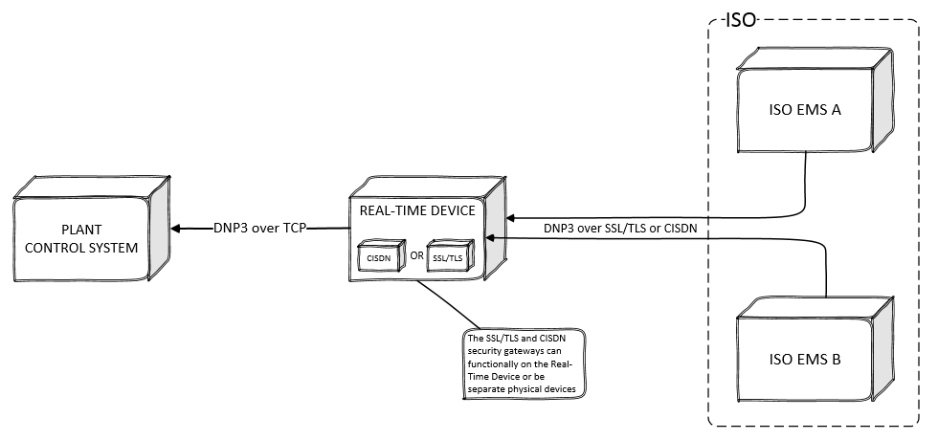

Exhibit 5-10 identifies, by number, the critical aspects of the ISO Real-Time Device. The diagram represents a high-level overview of the perceived functionality of an acceptable Real-Time Device in a single hardware device. This diagram is an illustration only. The interfaces, envisioned through an abstraction of the internal functionality of the hardware device, are numbered and described below.

Exhibit 5-10: Real-Time Device Hardware Option Functional Diagram

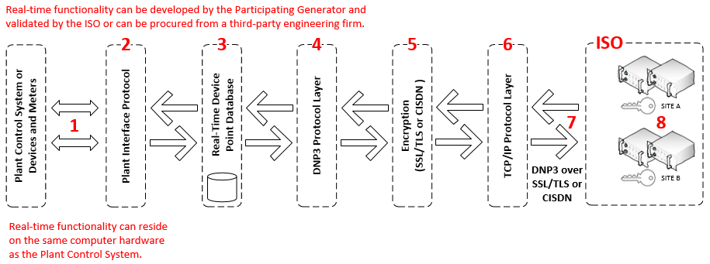

1. **Plant Interface Protocol**: The input to the Real-Time Device is a data stream compatible with the plant systems. This may also be individual hardwired inputs.
2. **Internal Plant Interface Protocol Layer**: The input data stream is received internally by an interface layer compatible with the plant systems.
3. **Real-Time Device Point Database / DNP3 Database Profile Specifics**: The input data is processed internally in the Real-Time Device as data points in a DNP3-compatible database structure. Since the real-time data must be compliant with DNP3 Level 1 protocol, and can contain a database large enough to require more than a single datalink frame for a Class 1 data response, the Real-Time Device must support both static and event-type data points. The Real-Time Device is required to support polling by class.

4. **DNP3 Output Interface Protocol Layer**: As the DNP3 server, the Real-Time Device will parse all client requests and supply the appropriate data designated in the Real-Time Device Point Database. This is typical of a DNP3 driver storing data into the real-Time database.

5. **SSL/TLS Encryption Layer**: In transferring the data from the Real-Time Device to a DNP3-compatible destination, elements are encrypted by a SSL/TLS encryption interface layer using ISO-issued basic-assurance digital certificates implemented either in the ECN or the public Internet.

6. **TCP/IP Output Interface Layer**: The Real-Time Device is to act as the TCP server/connection. Once the client device has requested and established the TCP connection, the encrypted DNP3-compatible data stream passes through an interface layer over a TCP/IP network.

7. **DNP3 over TCP/IP over SSL/TLS**: The DNP3 data stream is secured over TCP/IP using SSL/TLS encryption and transported over a TCP/IP network.

8. **ISO Multi-Porting Capability**: The Real-Time Device must have one IP address that has the ability to communicate with two simultaneously connections sourced from the ISO’s EMS.

## ISO EMS Interrogations

The ISO’s EMS DNP3 front-end processors interrogate each Real-Time Device with DNP3 Object 60, Variations 2 for event data polling (**class 1 data**). Responses shall be the event objects and variations listed below. If there is no points designated as class 1 then the ISO will be instructed by the DNP3 Real-Time Device that protocol driver of data in another class, this is handled and inherent to the DNP3 driver.

The ISO’s EMS DNP3 front-end processors interrogate each Real-Time Device with DNP3 Object 01 Variation 00 “digital static updates” and Object 30 Variation 00 for “analog static updates.” The Real-Time Device response must be among the Static Objects and Variations.

## DNP3 Object and Variation Types for Real-Time Device Responses

Objects and Variations supported by the Real-Time Device must include, but are not limited to:

* Static: Object 1 Variation 2 (Digital)

Object 30 Variation 2 (Analog)

* Event: Object 2 Variation 1 (Digital)

Object 32 Variation 2 (Analog)

* Time: Object 50 Variation 1 (Read and Write)
* Control: Object Type 41 (Analog Setpoint) Variation 2

***Important***

The ISO’s EMS DNP3 front-end processors will use DNP3 group and variations other than those listed above. All Real-Time Device solutions must be DNP3 Level 1 certified.

Deadband: Analog events should be set to .5 Engineering Units. The deadband must be configurable on a point-by-point basis. Exception for the analog deadband is analog points associated with wind, solar, and PDR resources. These types of resources have a much smaller deadband requirement and higher resolution. Consult ISO EDAS for proper deadband settings.

## Quality Flag Propagation to DNP3

When a Participating Generator installs a Real-Time Device and it communicates to downstream devices that are not directly connected to the Real-Time Device, the *originating* device(s) shall propagate a data quality communication flag for each point to the Real-Time Device through each *non-originating* *device*. A data port alarm point may not be required; however, this will be determined by ISO Energy Data Acquisition Specialist. Other protocols with data quality flags maybe used to propagate flags into DNP3 flags (OPC).

An *originating device* is one that gathers field data directly (for inputs) or issues controls directly to the field (for outputs). A *non-originating device* is one that obtains input data or issues control commands via a communications link from *originating* or *non-originating devices*. A *reporting device* is a device that acts as a DNP3 outstation, sending DNP3 messages to an upstream device.

Data from an originating device may arrive at the master via one or more data concentrator devices. In this case, each device in the communications chain, other than the master, is a reporting device. Exhibit 5-11 illustrates device identification. The terms “upstream” and “downstream” that indicate relative device hierarchy are also shown in this diagram.

Exhibit 5-11: Upstream and Downstream Device Identification



A COMM_LOST indicator indicates that there is a communication failure in the path between the device where the data originates and the reporting device on a point to point basis. This flag indicates that the value reported for the object may be stale or in bad quality. If set, the data value reported shall be the last value available from the originating device before communications were lost.

An *originating device* never sets this flag. A *non-originating or master* *device* sets this flag if it loses communication with the adjacent downstream device; otherwise it propagates the state of COMM_LOST flag as received from the downstream device. Once set, this flag may only be cleared when data for this point is received from the adjacent downstream device and the COMM_LOST flag received with that data is cleared.

## Maximum MW Real-Time Device Limitation

The ISO’s grid and market operations depend on data from a Real-Time Device to reliably run real-time operations, the Full Network Model, and the State Estimator. To minimize potential impact to the ISO’s grid and market operations, the ISO sets a maximum MW limitation. The limitation is set to protect the ISO’s markets and grid, should a Real-Time Device failure occur.

The maximum generation that can be put on a single Real-Time Device cannot exceed 1200 MW from a physical location. This includes the ECN circuit and router. The ISO reserves the right to review all proposed telemetry systems for compliance with this and other Real-Time Device limitations.

For Eligible Intermittent Resources and real-time Aggregators, the maximum combined generation for a single device, including the communication circuit and router, is 1200 MW.

## Real-Time Device Location Requirements

The purpose of a real-time location requirement is to limit the impact of possible real-time failures to a smaller geographical area. Location limits are defined by the standard 23 Sub-LAPs within the ISO Balancing Authority Area. The location limitation provides that only resources within a Sub-LAP can be aggregated within a Real-Time Device. The Real-Time Device shall reside within the Sub-LAP for the resources it is aggregating.

The ISO can make an exception to the location limits for aggregating resources within a Real-Time Device if a resource is located in an adjacent Sub-LAP that does not have a Real-Time Device.

A Real-Time Device Aggregator can combine multiple physical resource locations within a Sub-LAP. The MW limitation and limitation of aggregation location to Sub-LAPs is due to the unpredictable nature of these resource types (that is, solar and wind). Only a ISO Energy Data Acquisition Specialist may authorize an exception to location limits. The list of the Sub-LAPs is set forth in Section 19.

These limitations do not apply if a Real-Time Device Aggregator desires to transmit real-time data to the ISO for information only. The Real-Time Device location limitations do not apply to Real-Time Devices used in the transmission of real-time data by Demand Response Providers (DRP) to the ISO for Proxy Demand Resources.

## Real-Time Device Market Resource Limitation

The purpose of a resource limit is to mitigate the impact of a Real-Time Device failure on the ISO’s market Model State Estimator. If the ISO loses communication with many resources at once, it may impact the ISO’s modeling calculations. To mitigate this risk, the ISO has set the resource limit for a single Real-Time Device to 25 Resource IDs, subject to defined MW limits.

## Cost Responsibility

Each Participating Generator will be responsible for all costs incurred for Real-Time Device procurement and installation for the purpose of meeting its obligations under this ISO BPM, notwithstanding other ISO policies, procedures, and contracts that may affect the distribution of costs to participating parties.

# Telemetry Data Points List

The following values are the minimum requirements for real-time visibility of each resource. The ISO’s Operations & Engineering groups have approved these requirements. They are the minimum standards that will allow the ISO to manage effectively the reliability of the grid. At any time, the ISO may require additional points to be added to meet real-time requirements. The following points must be provided for each resource in the specified category. The Participating Generator must obtain the required point list from an ISO Energy Data Acquisition Specialist.

## Point Matrix

The following pages represent the minimum point requirement matrix for each type of Real-Time Device configuration that the ISO requires for real-time control or monitoring. The matrix specifies the telemetry points required for the following categories of resources:

**AGC**: Resources certified to provide Regulation in the ISO Markets.

**Spinning Reserve**: Resources certified to provide Spinning Reserve in the ISO Markets.

**Non-Spinning Reserve**: Resources certified to provide Non-Spinning Reserve in the ISO Markets.

**QF Conversion**: Resources that are Qualifying Facilities not exempt from ISO Tariff telemetry requirements pursuant to pre-existing agreements. Note that MW, MVAR, and voltage values are measured based on the Point of Demarcation for a Net Scheduled subject to a NS PGA.

**Energy Only**: Resources that provide Energy only.

**PDR**: Proxy Demand Resources.

**Solar**: Solar resources.

**Wind**: Wind resources.

If a resource falls within more than one category, the Participating Generator or Real-Time Aggregator must provide the telemetry points specified for each applicable category.

*Real-Time Point Definitions* in this document has the detailed definitions in Table 6-1.

Table 6-1: Required Real-Time Points by Technology or Service

*Notes to* Analog and Digital Notes *in the next section.*

| **Analogs** | **AGC** | **Spinning Reserve** | **Non-Spinning Reserve** | **QF Conversion** | **Energy Only** | **PDR** | **Solar** | **Wind** | **Solar/Wind less than 10MW** | **Battery** |
| --- | --- | --- | --- | --- | --- | --- | --- | --- | --- | --- |
| Unit Gross MW | X | X | X | X Note 9 | X | X Note 10 | X | X |  |  |
| Unit Net MW | X Note 1 | X Note 1 | X Note 1 | X Note 1 & 9 | X Note 1 |  | XNote 1 |  |  |  |
| Unit Point of delivery MW | X | X | X | X | X |  | X | X | X | X |
| Unit Auxiliary MW | X Note 2 | X Note 2 | X Note 2 | X Note 2 & 9 | X Note 2 |  | XNote 1 |  |  |  |
| Pseudo Gen MW |  |  |  |  |  | X |  |  |  |  |
| Bias Load MW |  |  |  |  |  | X |  |  |  |  |
| Unit Generator Terminal Voltage | X | X | X | X | X |  | X | X | XNote 12 | X |
| Unit Gross MVAR | X | X | X | XNote 9 | X |  | X | X |  |  |
| Unit Net MVAR | X Note 3 | X Note 3 | X Note 3 | X Note 3 & 9 | X Note 3 |  | XNote 3 |  |  |  |
| Point of delivery MVAR | X | X | X | X | X |  | X | X | X | X |
| Auxiliary MVAR | X Note 4 | X Note 4 | X Note 4 | X Note 4 & 9 | X Note 4 |  | XNote 3 |  |  |  |
| Capacitor Bank VAR |  |  |  |  |  |  | X | X |  |  |
| High\Line Side Bank MW | X Note 5 | X Note 5 | X Note 5 | X Note 5 | X Note 5 |  | X | X |  |  |
| High\Line Side Bank MVAR | X Note 5 | X Note 5 | X Note 5 | X Note 5 | X Note 5 |  | X | X |  |  |
| High\Line Side Bank Voltage | X Note 5 | X Note 5 | X Note 5 | X Note 5 | X Note 5 |  | X | X |  |  |
| Aggregated Gross MW | X Note 6 | X Note 6 | X Note 6 | X Note 9 | X Note 6 | X Note 10 |  |  |  |  |
| Aggregated Net MW | X Note 6 | X Note 6 | X Note 6 | X Note 9 | X Note 6 |  |  |  |  |  |
| Aggregated Point of delivery MW | X Note 6 | X Note 6 | X Note 6 | X Note 6 | X Note 6 |  |  |  |  |  |
| Aggregated Gross MVAR | X Note 6 | X Note 6 | X Note 6 | X Note 6 | X Note 6 |  |  |  |  |  |
| Resource ID Setpoint Feedback | X |  |  |  |  |  |  |  |  |  |
| RIG Heart Beat | X | X | X | X | X | X | X | X | X | X |
| Aggregate\Unit Operating High Limit | X |  |  |  |  |  |  |  |  |  |
| Aggregate\Unit Operating Low Limit | X |  |  |  |  |  |  |  |  |  |
| Wind Speed (Meter / Second) |  |  |  |  |  |  | X | X | X |  |
| Wind Direction (Degrees - Zero North 90CW) |  |  |  |  |  |  | X | X | X |  |
| Air Temperature (Degrees Celsius) |  |  |  |  |  |  | X | X | X |  |
| Barometric Pressure (HPA) |  |  |  |  |  |  | X | X | X |  |
| Back Panel Temperature (Degree C) |  |  |  |  |  |  | X Note 11 |  | X Note 11 |  |
| Plane Of Array Irradiance Watts\Meter Sq. |  |  |  |  |  |  | X Note 11 |  | X Note 11 |  |
| Global Horizontal Irradiance Watts\Meter Sq. |  |  |  |  |  |  | X Note 11 |  | X Note 11 |  |
| Direct Irradiance Watts\Meter Sq. |  |  |  |  |  |  | X Note 11 |  | X Note 11 |  |
| Diffused Plane Of Array Irradiance Watts\Meter Sq. |  |  |  |  |  |  | X Note 11 |  | X Note 11 |  |
| Diffused Global Horizontal Irradiance Watts\Meter Sq. |  |  |  |  |  |  | X Note 11 |  | X Note 11 |  |
| Reference Cell (MW @ .001 resolution) |  |  |  |  |  |  | X Note 11 |  | X Note 11 |  |
| Instantaneous State of charge |  |  |  |  |  |  |  |  |  | X |
| Maximum Continuous Energy limit |  |  |  |  |  |  |  |  |  | X |

| **Digitals** | **AGC** | **Spinning Reserve** | **Non-Spinning Reserve** | **QF Conversion** | **Energy Only** | **PDR** | **Solar** | **Wind** | **Solar/Wind Less Than 10MW** | **Battery** |
| --- | --- | --- | --- | --- | --- | --- | --- | --- | --- | --- |
| Unit\Resource Connect | X | X | X | X | X |  | X | X | X | X |
| PDR Resource Connect |  |  |  |  |  | X |  |  |  |  |
| Power System Stabilizer | X Note 7 | X Note 7 | X Note 7 | X Note 7 | X Note 7 |  |  |  |  |  |
| Automatic Voltage Regulator | X Note 7 | X Note 7 | X Note 7 | X Note 7 | X Note 7 |  | X Note 7 |  |  |  |
| Capacitor Bank Breakers |  |  |  |  |  |  | X | X |  |  |
| Unit Low Side Breaker | X | X | X | X | X |  | X | X | XNote 13 |  |
| Related Unit Breakers | X | X | X | X | X |  | X | X |  | X |
| Related Unit MOD's Disconnects | X | X | X | X | X |  | X | X |  |  |
| Switchyard Line Breakers (if Generator Owned) | X | X | X | X | X |  | X | X |  |  |
| Switchyard Line MOD (if Generator Owned) | X | X | X | X | X |  | X | X |  |  |
| Aggregated\Unit Connected | X Note 6 | X Note 6 | X Note 6 | X Note 6 | X Note 6 | X Note 6 |  |  |  |  |
| Aggregated\Unit Authority Switch | X Note 8 |  |  |  |  |  |  |  |  |  |
| Aggregated\Unit Control Switch | X Note 8 |  |  |  |  |  |  |  |  |  |
| Aggregated\Unit Automatic Generation Control | X Note 8 |  |  |  |  |  |  |  |  |  |

## Analog and Digital Notes

1. If Aux MW are over 1 MW then Net MW are required.
2. Required If Aux MW are over 1 MW.
3. If Aux MW are over 1 MW then Net MVR are required.
4. Required if Aux MW are over 1 MW.
5. Transformer High Side or Line values required depending on meter location.
6. Provide Unit Connected and Gross MW for each unit and aggregated values if Resource ID is an aggregate. Individual POD not required if the Resource ID is an aggregate.
7. PSS / AVR indication is needed if plant is required to install these devices.
8. Required point for each Resource ID.
9. Required if the QF is not subject to a QF Participating Generator Agreement.
10. Resolution @ .001 Gross MW = POD.
11. See the Solar Meteorological Data Tables in Section 13.5 and definitions of data points in Section 17.4. Note that some data points are not required from solar thermal facilities.
12. Voltage from ISO meter at metering point
13. This does not have to be an actual circuit breaker but an indication from some device within the system showing when the resource is physically connected or disconnected to the grid. One point only per resource

# Availability and Maintenance

## ISO Reliability Requirements

The Participating Generator shall be responsible for maintaining the availability of the Real-Time Device, all Real-Time Device interface systems, and Real-Time Device communications access to the communication network either to the ISP or ECN.

Risk of loss, theft, or damage of the Real-Time Device will be the responsibility of the Participating Generator.

A Participating Generator will be solely responsible, at the Participating Generator’s cost, for preparing and maintaining the site at which a Real-Time Device will be installed, and for engineering, installation, operation, and maintenance of that Real-Time Device and all other activities associated with the installation, operation, and maintenance of that Real-Time Device; except that this provision does not supersede agreements addressing responsibility for costs of engineering, design, installation, and testing set forth in any agreement for the installation of a Real-Time Device. The ISO will provide support as described herein to ensure that the Real-Time Device properly interfaces with the ISO’s EMS.

The local communications access circuit generally represents the highest risk to plant interface availability. Proper engineering of circuit pathways with alternate paths and redundancy wherever feasible is recommended. In all cases, the ISO recommends that the Participating Generator consider implementing a backup circuit to maintain communications.

A Participating Generator of a Real-Time Device is responsible for:

* Meeting the ISO network security requirements of either using SSL/TLS or Dispersive encryption methods
* Acting as the main point of contact for any data quality issue.
* Ensuring the accuracy of the data transmitted to the ISO.
* Resolving any data quality issues identified by the ISO.
* For a Real-Time Device Aggregator, see Section 15.

## ISO-Controlled Grid Operation and Market Availability Requirement

A Participating Generator is solely responsible for all costs and other consequences associated with the unavailability of the Real-Time Device and the inability of the Real-Time Device to communicate with the ISO’s EMS, including any financial consequences pursuant to the terms of the ISO Tariff. Such failure may result in penalties for failure to perform in accordance with the terms of the ISO Tariff. Additionally, the Participating Generator’s certification to provide Ancillary Services may be affected in accordance with the provisions of Sections 8.9 and 8.10 and other provisions of the ISO Tariff.

## Real-Time Device Operation and Maintenance

This section describes the notification and interface requirements for the following activities:

* Software upgrades
* Database revisions
* Routine testing and maintenance

The Participating Generator is responsible for all activities associated with the operation and maintenance (O&M) of the Real-Time Device. Exhibit 7-1 illustrates the boundaries of O&M responsibility for system maintenance for the ISO, the Participating Generator, and a telecommunications provider. The ISO is responsible for the O&M of ISO systems such as the EMS and the SCADA equipment connecting to the ECN or to the public Internet. The telecommunications provider is responsible for O&M of the WAN links between the ISO and the Participating Generator. The Participating Generator is responsible for O&M of plant systems of operating and maintaining the plant systems, the Real-Time Device, and the network connection to the ECN or to public Internet.

Exhibit 7-1: Operation and Maintenance Boundaries

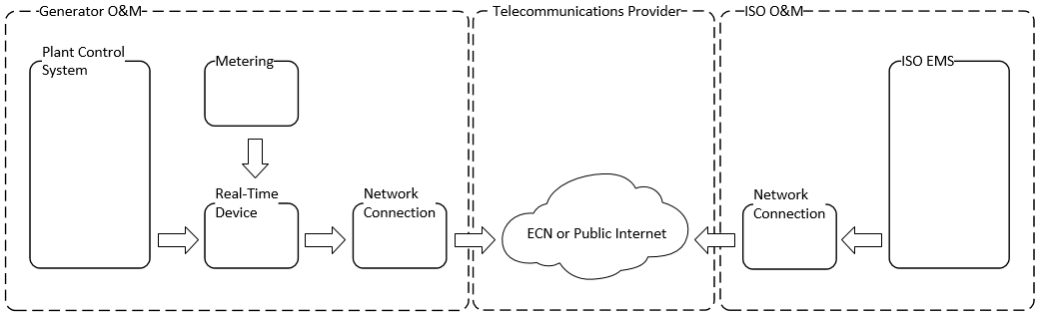

### Coordination of Changes to the Real-Time Device

The intent of this section is to provide a process for notification and approval for installation of upgrades to the Real-Time Device as requested by a Participating Generator or required by the ISO, based on the understanding that the overall functionality of the system must be ensured during upgrades without adversely affecting the ISO’s EMS.

The Participating Generator must safeguard and protect the Real-Time Device (hardware or software or both) and must treat the Real-Time Device as its own confidential business property. The Participating Generator must ensure that no person having access to the Real-Time Device attempts to modify or reverse engineer the Real-Time Device software. The Participating Generator must also take reasonable steps to ensure that all persons having access to the Real-Time Device observe the Participating Generator’s obligations relating to the Real-Time Device.

The ISO maintains a database that contains, for each Real-Time Device, the data points required from the Real-Time Point Definitions contained in this document. This Real-Time Device database may also contain additional data as required for mapping to the ISO’s EMS. In order to maintain operation of the EMS, the ISO requires prior notification and approval of all revisions to this Real-Time Device database.

A Participating Generator may make modifications to its Real-Time Device to support its operations, including the addition of data input/output points (which may or may not be made available to the ISO) and the addition or replacement of hardware, as required to accomplish the Participating Generator’s purposes, provided that:

* The Participating Generator coordinates such changes with the ISO and first obtains from an ISO Energy Data Acquisition Specialist the relevant information from the latest revision of the ISO database of Real-Time Devices.
* The Participating Generator remains solely responsible for all costs and other consequences associated with any interruption, as a result of such changes or modifications, in the ability of the Real-Time Device to communicate with the ISO’s EMS, including financial consequences, according to the ISO Tariff.
* The Participating Generator notifies the ISO at least seven days prior to any revision.
* The Participating Generator submits a database revision for review by an ISO Energy Data Acquisition Specialist and clearly states the proposed database changes, including the new revision, the installation date, and a valid OMS outage number.
* Following ISO approval of the database revision request, the Participating Generator adheres to the requirements contained in this document during the installation of the changes.
* The Participating Generator notifies the ISO before installation of the changes and participates with the ISO in joint testing prior to placing the Real-Time Device back in service.

The ISO requires prior notification and approval of all vendor software upgrades to the Real-Time Device in order to assure that the changes do not have an adverse impact on the ISO’s EMS. The Participating Generator’s obligations are as follows:

* The Participating Generator must notify the ISO at least seven days prior to any software upgrade installation.
* The Participating Generator must provide a valid OMS outage number that clearly covers the software upgrade. (For more information outage coordination, see ISO documentation on Outage Coordination under References.)
* Upon the ISO’s approval of the software upgrade installation request, and during installation of the upgrade, the Participating Generator must adhere to all requirements contained in this document and must follow all Outage Coordination process in accordance with the ISO Tariff.
* The Participating Generator must notify an ISO Energy Data Acquisition Specialist before installation of any software upgrade affecting a Real-Time Device.

### Database Configuration and Management Affecting the ISO’s EMS

The intent of this section is to provide a process for changes to a Real-Time Device database in the event of modifications, either by the ISO or by the Participating Generator, that affect the functionality of the ISO’s EMS software or database.

* In the event that the ISO requires changes, the ISO will notify each affected Participating Generator 120 days in advance of such changes and will provide a detailed explanation of the changes to be made.
* In the event that the Participating Generator requires changes to the Real-Time Device database that affect the ISO’s EMS software or database, the Participating Generator must contact a ISO Energy Data Acquisition Specialist 120 days in advance of the requested change.
  + In this case, the Participating Generator is responsible for making any necessary conforming changes to the Real-Time Device to maintain the interface with the ISO’s EMS.
  + The ISO will work with Participating Generators to stage the work so that no Generating Unit will be adversely affected in its ability to provide Regulation due to the unavailability of the human resources required to accomplish the changes.
* Any such modifications or changes must not compromise the Participating Generator’s right or ability to restrict access to information associated with the Participating Generator’s resources by any party.

### Routine Testing and Maintenance of Real-Time Devices

The Participating Generator is solely responsible for the completeness and accuracy of all information transmitted by a resource to the Real-Time Device. The ISO will not be responsible for the quality of the data transmitted through the Real-Time Device; the ISO will only validate this information for accuracy. The ISO and the Participating Generator must monitor the Participating Generator’s data transmitted through the Real-Time Device and, upon observation of any problems with that data, either party must provide the other party notice of the problem and both must work together to correct the problem.

The Participating Generator is responsible for all routine testing and maintenance of the real-time devices RIGs. The intent is to provide resource owners with the process to follow in order to maximize RIG operation while periodic maintenance and/or testing is performed. Minimizing the loss of real-time device RIG communication, and thereby minimizing the period when a resource is unavailable for bidding in the Ancillary Services markets, is in the best interest of both the resource owner and the CAISO. The resource owner must also avoid sending spurious or inaccurate data through the RIG real-time device as a result of testing and maintenance activities without first coordinating test plans and actions with the CAISO. Spurious and inaccurate data sent through a real-time device RIG to the CAISO and which the CAISO is not expecting to receive will impact the CAISO’s real time Balancing Authority Area load and reserve requirements calculations and its markets.

* Planned periodic maintenance and testing of the Real-Time Devices should be performed during scheduled resource outages.
* The Participating Generator understands that loss of Real-Time Device communication will result in the inability of the resource to participate in Ancillary Services markets.
* In the event that a resource has failed to communicate or provide telemetry for seven calendar days (consecutive or nonconsecutive), the ISO will send a letter to the Scheduling Coordinator. If compliance issue are not resolved within 30 days, the ISO will send an additional letter to inform the Participating Generator and Scheduling Coordinator that the resource’s ability to participate in Energy or Ancillary Services markets may be removed.
* Outages must be requested through the resource’s Scheduling Coordinator. Planned work on Real-Time Devices should take place only between the hours of 8:00 am and 4:00 pm Pacific time, Monday through Friday, excluding ISO holidays. (For more information, see ISO documentation on Outage Coordination under References.)

# Real-Time Device Implementation

## Engineering and Deployment

The Participating Generator is responsible for all procurement, engineering services, and maintenance with regard to the installation of the Real-Time Device. The ISO suggests that the first step in the installation process be that the resource coordinates a “kick off” meeting.

## Real-Time Device Database Development

The ISO’s Real-Time Device Engineer will provide technical assistance as required to the Participating Generator during the Real-Time Device hardware selection process. ISO EDAS will also provide assistance during the development of the Real-Time Device database.

## Telecommunication Circuit Installation and Power Requirements

The Participating Generator may obtain communication access circuit(s) from the ECN provider or an ISP provider. The LEC is responsible to provide the circuit to the plant main point of entry (MPOE) only. It is the Participating Generator’s responsibility to provide for, or contract services for, the implementation of high voltage protection (HVP) for these circuits where required. It is also the Participating Generator’s responsibility to provide on-site extension of the communication network circuit(s) to the actual Real-Time Device cabinet location on-site.

All service power to communication equipment and the Real-Time Device must be powered by an uninterruptable power supply (UPS) for the same amount of time the LEC is providing. This is not limited to Real-Time Device router, fiber optic power on both ends of the cabling, and [Channel Service Unit](http://en.wikipedia.org/wiki/Channel_service_unit)/[Data Service Unit](http://en.wikipedia.org/wiki/Data_service_unit) (DSUCSU). Any communication equipment and device providing communications to the Real-Time Device must install a UPS or equivalent. For Eligible Intermittent Resources, see *Power Reliability Requirements* in this document.

## Temporary Telemetry Exemptions

The ISO may grant a temporary telemetry exemption for a resource that is new to participation in the ISO’s markets or that currently exists in the ISO’s markets, but an exemption is not guaranteed. The exemption is used for a Participating Generator that is unable to comply with applicable telemetry requirements prior to the transition of its resource to commercial operations in the ISO’s markets, or for which telemetry is lost or not in good quality during participation in the ISO’s markets. Temporary telemetry exemptions are focused on particular data. A Participating Generator must provide all required documentation in order to submit a request for a telemetry exemption.

8.4.1 – Pre-Commercial Units

Units that are working to complete the process to begin operating commercially in the ISO’s markets, but have not completed all aspects of the project to provide required telemetry to the ISO, may request a temporary exemption from the ISO Tariff section 7.6.1(d).

The temporary telemetry exemption form can be found on the ISO website under Participate\Metering and Telemetry, and should be submitted to the ISO as per the instructions on the form.

The ISO may accept or not accept the temporary telemetry exemption request as noted in the Telemetry Requirements Exemption Policy included as Attachment 1 to the form.

8.4.2 – Commercial Units

Upon notification from the ISO that either a telemetry failure has occurred or telemetry is in bad quality that impacts the following points (Unit Point of Delivery MW, Unit\Resource Connect, Back Panel Temperature, Irradiance, Wind Speed or Wind Direction), a resource owner is responsible for expeditiously investigating and resolving the issue to remain compliant with ISO Tariff section 7.6.1(d).

A telemetry failure is defined as having occurred when the data for either the Unit Point of Delivery MW or the Unit\Resource Connection point has not been provided for 30-minutes for resources >= 45 MWs and 60-minutes for resources < 45 MWs. For the Back Panel Temperature, Irradiance, Wind Speed or Wind Direction points, a telemetry failure is defined as having occurred when the data for these points has not been provided for 24-hours.

Upon notification to the resource owner and its Scheduling Coordinator of the telemetry issue, the Scheduling Coordinator will create a telemetry outage using the Outage Management System (OMS) and will contact the resource owner to resolve the issue or request an exemption from the ISO for providing the telemetry data by the following deadlines:

* (5) Business days after notification of the telemetry issue for resources >= 45 MW’s.
* (14) Business days after notification of the telemetry issue for resources < 45 MW’s.

**Note**: These MW thresholds will also apply to failures associated with an aggregated RTU where multiple smaller resources submit telemetry data to the ISO via one RTU.

During the time that good quality telemetry data is not being automatically provided to the ISO through the RTU, telemetry value updates will be expected to be verbally provided to the ISO by the Scheduling Coordinator as follows:

* For plants with a total capacity < 10 MW, no reports of changes are required, other than the status of resolution of the telemetry issue.
* For plants with a total capacity of 10 – 500 MW, report every 25 MW change and report plant status changes (online, offline, configuration change).
* For plants with a total capacity of > 500 MW, report every 50 MW change and report plant status changes (online, offline, configuration change).

If a resource is certified to provide Ancillary Services, the resource shall not bid into the Ancillary Service market or self-provide Ancillary Services. Any awards or self provision already in place at the time of the telemetry failure would be subject to buy-back and possibly other settlement consequences.

The temporary telemetry exemption form can be found on the ISO website under Participate\Metering and Telemetry, and should be submitted to the ISO as per the instructions on the form. Information required to be provided to the ISO on the form includes a detailed description of the issue, the steps being taken to resolve it and the expected date of resolution of the issue.

The ISO will review the submitted telemetry exemption request and respond back to the resource owner and its Scheduling Coordinator as follows:

* If a telemetry exemption request is not accepted by the ISO, the ISO will notify the resource owner and its Scheduling Coordinator, and provide guidance regarding what aspect of the request was not acceptable to the ISO. A new telemetry exemption request addressing the unacceptable aspect of the previous submission must be submitted to the ISO within (5) business days of the deficiency notification from the ISO.
* If the telemetry exemption request is accepted by the ISO, the ISO will notify the resource owner and its Scheduling Coordinator, and will expect the issue to be resolved no later than the time identified in the accepted telemetry exemption request.
* If the telemetry issue cannot be resolved by the date committed to in the accepted telemetry exemption request, another telemetry exemption request must be submitted prior to the expiration of any existing accepted telemetry exemption that explains the delay and provides a new date for resolution of the issue.

**Note**: The ISO may accept or not accept the new telemetry exemption request as noted in the Telemetry Requirements Exemption Policy included as Attachment 1 to the form.

Failure to resolve the telemetry issue by the end of an accepted telemetry exemption period, or to submit a telemetry exemption request or telemetry data as per the guidelines documented in this BPM section will result in a Rules of Conduct violation as per ISO Tariff section 37.6, and penalties will be assessed accordingly to the Scheduling Coordinator of the resource.

* Resolution of the telemetry issue will be considered complete when the telemetry data in question has been received in good quality for (72) consecutive hours.
* For the purposes of penalties assessed as per ISO Tariff section 37.6, the days associated with the (72) consecutive hours of good quality data will not be considered as the resolution of the issue will be deemed to have occurred at the beginning of the (72) hour period.

If the resource owner fails to work diligently to resolve the telemetry issue, the ISO will provide formal notification to the resource owner and its Scheduling Coordinator that the resource is not compliant with the ISO Tariff section 7.6.1(d) and therefore in breach of their contract with the ISO. The ISO will then proceed as per the parameters outlined in their contract with the ISO to have the resource associated with the telemetry failure removed from the Schedule 1 of their contract with the ISO. Upon removal from the Schedule 1 of their contract with the ISO, the Scheduling Coordinator association for the resource will also be terminated.

# FNM Database Process and Real-Time Installation

The FNM database process and Real-Time Device installation for real-time telemetry data section references the required steps for new and existing Real-Time Devices entering or maintaining the installation.

## ISO FNM Database Process

Section deprecated. See New Resource Implementation Timeline in References.

## New Database Submission

### Standards to Submit Real-Time Device Database for ISO Database Build

Section deprecated. See New Resource Implementation Timeline in References.

## Real-Time Database Submittal Timeline

Section deprecated. See New Resource Implementation Timeline in References.

## Network Physical Circuit Protection to the Resource

* Copper installation at the de-marc,
  + High-Voltage Protection (HVP) may be required by the Local Exchange Carrier (LEC)
  + Longer lead time (up to 90 days)
* Fiber optic installation at the demarc
  + Shorter lead time (30 to 60 days)
  + No HVP required in most cases

## Network Circuit Provisioning and Monitoring

### AT&T ECN or ANIRA IPsec VPN

* For the ECN option, the Participating Generator provides a router from an approved list of routers and contacts with AT&T to provision a T1 circuit.
* Alternatively, for the ANIRA option, the Participating Generator provides a broadband connection (Ethernet or cellular IP) to establish an Internet Protocol Security (IPsec) connection to the ECN; there is no need for the Participating Generator to provide an ECN router or a T1 circuit.
* For either option, the Participating Generator maintains an ISO-provisioned digital certificate to provide encryption over the ECN.
* AT&T optionally provides 24x7 router and circuit monitoring with same-day technician dispatch.
* The Participating Generator optionally contracts with a third-party integrator.

### Dispersive™ CISDN

* Dispersive Technologies provides a fully managed and monitored software-defined security and encryption service over the public Internet without requirement for ECN.
* Due to the software-defined nature of the security, the Dispersive™ CISDN option provides a high level of immunity to distributed denial-of-service (DDoS) and machine-in-the-middle (MitM) attacks.
* The Participating Generator contracts with Dispersive Technologies (or a Dispersive Technologies channel partner) to install and maintain a tamper- and temperature-resistant hardware security gateway.
* With this option, there is no requirement for an ECN connection; the service is optimized for a high level of security and reliability over the public Internet.
* With the Dispersive™ CISDN option, there is no need for the Participating Generator to request or maintain digital certificates.
* The Participating Generator provides a broadband link (Ethernet, DSL, cellular IP, satellite IP, or wireless).
* The Dispersive™ CISDN technology is able to aggregate multiple broadband link types into a single logical circuit to enhance reliability.

### Self-Maintained Network and Circuit Monitoring

* With this option, Participating Generators would provide or contract their own network and circuit monitoring and would be responsible for resolving any problems with the network circuit.

## Standards for Point-to-Point Testing with the ISO

Before a Participating Generator submits a request to test its Real-Time Device installation, the Participating Generator must pretest all data points to a DNP3 master simulating the ISO connection without security prior to the scheduled test date. This pretest is to assure quick testing with the ISO.

The Participating Generator has the responsibility to validate and notify the ISO that the DNP3 point-to-point pretesting is complete. Use the ISO Energy Data Acquisition Specialist E-mail Address in References to submit the notification. Without this notice, the schedule test date may be canceled.

**Methods of pretesting**

* DNP3 master emulator
* DNP3 master test set
* Other DNP3 software capable of polling the Real-Time Device

**Additional Real-Time Device configuration needed before final testing can be performed**

* Device PKI certificates installed
* Or Dispersive capabilities installed
* Review documentation provided by ISO

Important: It is essential that the Participating Generator perform pretesting with the Plant Control System and Revenue Meter through to a DNP3 master simulation before testing with the ISO. Manipulation of real-time data at the real-time is not an acceptable method of testing unless the Real-Time Device is the resource’s control system.

**Testing of points**

See the procedure for Acceptance Testing for Real-Time Devices under References for more information on the following. Each analog point must be tested to full, mid, and low scale. The ISO may, at its discretion, optionally allow other values.

* The On and Off state for each digital point must be verified.
* Calculated points must be tested by changing inputs to the calculation.
* Set Points will be tested to full, mid, and low scale.

**Revenue meter real-time point testing for a new real-time Installation**

* An ISO revenue meter used for any analog points must be tested by injecting voltage and current into the meter. Other types of transducers can be used in lieu of an ISO revenue meter.

**Revenue meter real-time point testing for an existing Real-Time Device installation**

* In this case, the Participating Generator may use a synced resource or a meter test to verify the real-time values.

Point testing with the ISO shall be undertaken as the last part of the testing and installation phase.

**The Participating Generator has the responsibility to complete all pretesting before scheduling CAISO testing. If not, a delay or rescheduling of CAISO testing may be required.**

## Required Personnel for Point testing

* At the scheduled RIG real-time device testing date, the following personnel are needed for testing:
  + Resource personnel capable of exercising each real-time point required to be sent to the CAISO’s EMS from the resource control system through the RIGreal-time device.
  + Integrator responsible for the RIG real-time device installation.
  + Revenue meter personnel who can inject test values into the meter to verify real-time data going to the CAISO’s EMS through the real-time device. The CAISO may make an exception to this requirement for an operating resource if it does not include new generation.
* Testing from the RIG real-time device to the CAISO’s EMS alone is not considered sufficient for a CAISO point test (i.e., plant control system to RIG real-time device to CAISO’s EMS).
* The final CAISOISO test will be complete at the time the resource is in Trial Operations or is an existing resource and it is running and synced to the grid.

## Real-Time Device Data Validation

* After the Real-Time Device has passed the point to point testing and the resource has synched to the ISO grid a 72 hour data test is performed. During this test, ISO shall test the following examples:
  + Un-interrupted communication connection to ISO
  + Un-interrupted Real-Time Device connection to downstream devices such as Revenue meter, Met station and SCADA systems.
  + All Analog and Digital data in good quality
  + All logics working as expected.

## Upgrade or Replacement of a Real-Time Device

* Standards of replacing, upgrading, or modifying an existing Real-Time Device:
  + The Participating Generator must submit an OMS Outage for some time during the period Monday-Friday between 8:00 a.m. and 4:00 pm only. The existing Real-Time Device must be returned to service after 4:00 pm daily.
  + The Participating Generator must provide 72 hours lead time for scheduled testing times.
  + A third-party engineering firm may not request the existing ISO spreadsheet directly from the ISO. The ISO must receive an e-mail from the Participating Generator granting permission for the ISO to provide the spreadsheet to the third party.
  + The ISO will verify the request with the Participating Generator.
  + The ISO will only give IP addresses to the Participating Generator, unless directed differently.
  + All other point testing discussed previously is required.
  + If the resource is operating, generally, calculated points (UCON) cannot be tested. These points will be verified when the resource shuts down.

## Outage Management for Meter or Real-Time Device work

The ISO Energy Data Acquisition Specialist group will not approve any work on a Real-Time Device or ISO revenue meter without an approved outage and a fieldwork appointment on the EDAS calendar.

Plant personnel will need to call an ISO Energy Data Acquisition Specialist at 916-608-5826 group before work can begin.

* Before the plant personnel calls, they must verify that:
  + The outage has a valid outage number.
  + The outage number is for the **actual** times, work, and equipment being performed.
  + The outage number has been **started** and the **OUT** (Active) state.
* The call is made to ISO Energy Data Acquisition Specialist, 916-608-5826 Plant\Generator personnel coordinates all work for:
  + Third Party Meter Engineers: They are to call the ISO Energy Data Acquisition Specialist group at the number above before removing a meter out of service.
* Real-time Integrators: They are to call the ISO Energy Data Acquisition Specialist group at the number above before starting work on a real-time. What ISO Real-Time Device Engineering is not responsible for:
  + Submitting the outage.
  + Starting the outage.
  + Obtaining the outage number.
  + Calling all the parties responsible.
* Taking the resource to the OUT (active) state. ISO Energy Data Acquisition Specialist Action with an outage.
  + Call the ISO Real-Time Operator before work starts.
  + Call the ISO’s service center (SMSC) about the pending work.
  + Manually Replace the resource’s current MW output for the FNM and EMS load calculation, and coordinate with the plant personnel to keep values current during the outage.

## Digital Certificates

When not using the Dispersive™ CISDN communications option, the Participating Generator must meet the following requirements to obtain an ISO-provisioned SSL/TLS digital certificate to secure Real-Time Device communications. See References for ISO Energy Data Acquisition Specialist e-mail address and phone number.

* Copy ISO EDAS on all certificate requests or correspondence.
* If the request is for a new installation, obtain the Common Name value for the Real-Time Device from ISO EDAS either by e-mail or phone.
* The ISO will ask if the Participating Generator intends to work with a third party to request, install, or renew a digital certificate.
* There is a ten-day lead time to provision digital certificates.
* All certificate requests must include a completed request with an attached Certificate Signing Request (CSR); see *Request Form for Digital Certificate for Real-Time Device* in References for the request form.
* Indicate on the form whether the request is for a new installation.
* The Participating Generator must e-mail the completed certificate request using the e-mail addresses listed in References under *E-mail Addresses for Submitting a Certificate Signing Request*.
* The Participating Generator must obtain an approved outage for the installation of the new digital certificate.
* At least two weeks prior to the expiration of an existing digital certificate, the Participating Generator must inform ISO EDAS of the outage scheduled to replace the certificate.
* ISO Energy Data Acquisition Specialist is not responsible for the timing of the renewal request sent by the Participating Generator.
* The Participating Generator can install the digital certificate on the Real-Time Device during the scheduled outage.
* The ISO will inform each Participating Generator of pending expiration of digital certificates at least two months prior to expiration. It is the responsibility of Participating Generators to remain aware of pending expiration of digital certificates and to watch for notices.

## Wind and Solar FNM Documentation Required

The additional requirements are covered in the Tariff Appendix Q must be provided by the Participating Generator for wind and solar resources.

# AGC Operational Requirements for Generating Units

## Required DNP3 and Telemetry Data Points for AGC

To meet the minimum requirement of real-time visibility for Generating Units providing Automatic Generation Control (AGC) to the ISO, each Real-Time Device must be capable of communicating the following types of values to/from the ISO’s EMS:

* Analog input values to the ISO
* Digital input values to the ISO
* Analog output (Set Points) from the ISO

To meet the minimum requirement of real-time visibility for Generating Units providing Automatic Generation Control (AGC) to the ISO, each Real-Time Device must be capable of communicating the following telemetry data points to/from the ISO’s EMS:

* Unit Control Switch (UCTL)
* Unit Authority Switch (UASW)
* Automatic generation control (UAGC)
* Automatic generation control Set Point
* Automatic generation control feedback
* Unit Operating High Limit (UOHL)
* Unit Operating Low Limit (UOLL)

For a detailed description of the minimum data point requirements for Generating Units providing AGC Regulation to the ISO please refer to Section 17.

The ISO Operations and Engineering groups have approved the list of data point requirements described herein. They are the minimum data point standards that will allow the ISO to manage effectively the reliability of the grid. **At any time, the ISO may require additional telemetry values to meet real-time operational requirements.**

## AGC Control (Bumpless Transfer)

For resources providing AGC, the Real-Time Device may have the option to set up a bump less transfer method for AGC control, to track Set Point when resources are off AGC control. A calculated Set Point will be stored in the Real-Time Device, continually updating with the current Point of Delivery MW value of the resource or aggregate resource. When the resource transfers to AGC control, and starts accepting valid Set Points, the calculation will deactivate. The calculation should only reactivate when AGC control is disengaged.

# Eligible Intermittent Resources (EIR)

## Applicability

The Eligible Intermittent Resources Protocol (EIRP) in Appendix Q of the ISO Tariff imposes various communication and forecasting equipment and forecasting data requirements on EIRs with PGAs as well as additional requirements on such EIRs electing certification as a Participating Intermittent Resource (PIR). Section A13 of Appendix A of the *BPM for Market Operations* contains additional requirements for EIRs and PIRs that do not pertain to direct telemetry.

## Power Reliability Requirements

The wind and solar EIR owner must provide a backup power source for the Real-Time Device, meteorological station equipment, revenue meter, and essential communication equipment (not limited to the router, network switch, fiber optic transceiver, and 120V plug-in power supplies), the backup power source shall be sized accordingly to carry that equipment load. A backup power supply may include, but is not limited to, uninterruptable power source (UPS), battery bank with solar panel charger, or dedicated wind turbine charging a backup battery bank with inverter. Whichever backup power source is installed, it shall be sized and provide power until the primary power source is restored.

## Basic Meteorological Data

The ISO required meteorological data points for EIRs participating in ISO markets as a VER is covered in the ISO tariff appendix Q section 3.

### Meteorological Wind Speed

The unit of measurement for wind speed will be in meters per seconds (m/s) with a precision of one m/s.

### Meteorological Wind Direction

The unit of measurement for wind direction will be in angular degrees from true north with a precision of five degrees.

### Meteorological Barometric Pressure

The unit of measurement for barometric pressure will be in Hecto Pascal with a precision of 60 Hecto Pascal.

### Meteorological Ambient Temperature

The unit of measurement for ambient temperature will be in degrees Celsius with a precision of 1 degree Celsius.

## Wind Generation

### Meteorological Station Requirements

Each Participating Generator with a wind EIR must install and maintain equipment required by the ISO to support accurate power generation forecasting and the communication of such forecast, meteorological, and other required data in accordance to ISO New Resource Implementation process timeframe and the tariff appendix Q. The use of SODAR and/or LIDAR equipment may be an acceptable substitute for wind direction and velocity based on consultation and agreement with the forecast service provider and the ISO.

### Designated Turbines

Designated Turbines are required to improve forecast accuracy within a wind Generator Facility.

Definitions:

Designated Turbine - A turbine designated by the ISO, in which nacelle wind speed and wind direction is required.

**Wind Site Information Form and Topographical Map**

A wind EIR must submit a in accordance to the New Resource Implementation process time frame and ISO Tariff Appendix Q the topographical map and the Wind Site Information Spreadsheet (see References) that has all the locations and heights for each wind turbine within a wind Generator Facility with latitude and longitude and shall be in degrees/decimals using WGS84 geodetic datum only. Note: “See topographical map” is not an acceptable input on the Wind Site Information form.

## Solar Generation

### Meteorological Station Requirements

Each EIR Generator Facility shall provide meteorological station(s) in accordance to the ISO tariff appendix Q. The meteorological real-time data requirements are set forth in Section 13.4.1.

Solar Generating Facilities that require direct normal irradiance (DNI) and global horizontal irradiance (GHI) measurements may provide alternate radiometry meteorological station data. For example, meteorological station one may report DNI where meteorological station 2 may report GHI. All other meteorological data reporting requirements shall remain the same.

Solar Generating Facilities’ meteorological stations shall cover 90% of the facility’s footprint for each Resource ID. Each meteorological station shall have a coverage radius of 7 miles.

### Basic Solar Meteorological Data

Table 11-1 has been removed and Tariff Appendix Q Section 3.2.2 has the devices list, Units of measure, and Accuracy.**.**

### Participating Generator Irradiance Component Requirements

Table 11-2 has been removed and Tariff Appendix Q Section 3.2.2 has the technology component requirements,

### Solar Technology Definitions

The technology definition are now covered in Tariff Appendix Q section 3 - TBD

#### Flat Plate Solar Photovoltaic

Photovoltaic power generation employs solar panels comprising a number of cells containing a photovoltaic material.

* **Fixed horizontal / flat roof:** The panels are mounted parallel to the sky and the roof top.
* **Fixed angle:**  The panel is statically fixed to an angle that optimizes its exposure to the sun year around.
* **Azimuth tracking:** A panel is attached to a device that tracks the horizontal movement of the sun to optimize solar production.
* **DNI:** Direct Normal Irradiance (DNI) is a measure of the solar irradiation striking a surface held normal to line of sight to the sun.
* **Solar zenith angle**: Zenith angle is the angle from the zenith (point directly overhead) to the sun's position in the sky. The zenith angle is dependent upon latitude, solar declination angle, and time of day.

#### Flat Panel Solar Collector

A typical flat-plate collector is a metal box with a glass or plastic cover (called glazing) on top and a dark-colored absorber plate on the bottom. The sides and bottom of the collector are usually insulated to minimize heat loss. Sunlight passes through the glazing and strikes the absorber plate, which heats up, changing solar energy into heat energy. The heat is transferred to liquid passing through pipes attached to the absorber plate.

#### Low Concentration Solar Photovoltaic

Low concentration solar photovoltaic is a system that has a solar concentration of 2-100 magnification of the suns**.** This is normally performed with the use of mirror or other material or devices that concentrate the suns irradiance.

#### High Concentration Solar Photovoltaic

High concentration solar photovoltaic is a system that has a solar concentration of 300 magnification of the suns or greater**.** This is normally performed with the use of mirror or other material or devices that concentrate the suns irradiance.

#### Concentrated Solar Thermal

Concentrated solar thermal systems use lenses or mirrors and tracking systems to focus a large area of sunlight onto a small area. The concentrated light is then used as heat or as a heat source for a conventional power plant such as a steam turbine.

#### Heliostat Power

Heliostat power plants or power towers are a type of solar furnace using a tower to receive the focused sunlight. They use an array of flat, movable mirrors called heliostats to focus the sun's rays upon a collector tower.

#### Greenhouse Power Tower

The greenhouse power tower combines the chimney effect, the greenhouse effect, and wind turbines to produce power. Air is heated by sunshine and contained in a very large greenhouse-like structure around the base of a tall chimney, and the resulting convection causes air to rise up the updraft tower. This airflow drives turbines, which produce electricity.

#### Sterling Engine

Sterling engine use the expansion or hot gasses and contraction of cool gasses to produce mechanical work. The engine is designed so that the working gas is generally compressed in the colder portion of the engine and expanded in the hotter portion resulting in a net conversion of heat into work. The cooler part of the engine at times has compressors to cool the gases, and the hotter part, uses mirrors to concentrate the heat from the sun.

### Solar Site Information Form and Topographical Map

A Participating Generator solar EIR must submit a in accordance to the New Resource Implementation process time frame and ISO Tariff Appendix Q the topographical map and the Solar Site Information Spreadsheet (see References) for locations and heights for each wind turbine within a wind Generator Facility with latitude and longitude and shall be in degrees/decimals using WGS84 geodetic datum only.

# Proxy Demand Resource (PDR)

Proxy Demand Resources shall follow the direct telemetry standards defined in this BPM. Check section: Refer to Section 6.2.2 for telemetry timing requirements.

## PDR Point Requirements

### Real Load MW

Each PDR shall be required to provide real-time load values. The load is the total real-time load or the power consumed by the resource; it can be a directly measured or calculated. Load data can be provided directly from a field device, such as a revenue meter, or indirectly by interfacing to a PDR EMS. It can also be derived by statistical sampling of a resource’s underlying load. This data point is used to help establish a baseline and calculate the load reduction of a resource when the resource is dispatched. A method for calculating load is not valid unless approved by the ISO.

### PDR Unit Connectivity Status (PDR UCON)

The PDR UCON can be manually set by an operator or programmed to change status based on an ADS Dispatch. The PDR UCON represents connection of the resource to the grid.

### Bias Load

Bias load is a calculated value that stores the initial real load of a resource when the PDR unit connectivity status (UCON) is initially set to ON (HIGH). The bias load is used to establish a resource’s baseline load.

### PDR Unit Ready to Start and Start Status

The PDR Ready to Start and Start statuses are required only if a PDR is participating in the Spinning or Non-Spinning Reserve market. The Ready to Start status should be set to ON (HIGH) if the resource has been awarded Spinning or Non-Spinning Reserve by the market and is available for dispatches. The Start status should be set to ON (HIGH) when the PDR UCON is ON (HIGH). Both status points can be linked to the PDR UCON status.

### Pseudo Generation MW

PDR will be required to provide a pseudo generation point. The pseudo generation point calculates the real load, bias load, and the PDR UCON points. The pseudo generation point calculation can be performed within a control system, EMS, or Real-Time Device.

The pseudo generation point allows the ISO to model the PDR resources like a participating generator.

### Statuses and Pseudo Generation Flow

Table 12-1 shows the sequence of the ADS signal when it changes for a PDR. (The ISO’s ADS dispatches to non-regulation resources.)

Table 12-1: Sequence of ADS Signal for PDR

|  |  |  |  |
| --- | --- | --- | --- |
| **1A** | **If ADS Dispatch Signal > 0** | **1B** | **If ADS Dispatch Signal = Zero** |
|  | Read to Start status = 0 |  | Read to Start status = 1 |
|  | Start status = 1 |  | Start status = 0 |
|  | PDR UCON = 1 |  | PDR UCON = 0 |
|  | Real Load = Feeder Actual MW |  | Bias Load = 0 |
|  | Set Bias Load = Real Load |  | Pseudo Gen = 0 |
|  | Pseudo Gen = Bias Load - Real Load |  | Goto 1B |
|  |  |  |  |
| 2A | Loop checks the ADS dispatch every minute.  if ADS dispatch > 0 then next step else go to 1B |  |  |
|  | Reset Real Load = Feeder Actual MW |  |  |
|  | Perform Pseudo Gen = Bias Load - Real Load |  |  |
|  | Go to 2A |  |  |
|  |  |  |  |

Exhibit 12-2 illustrates the flow of PDR status and Pseudo Generation MW.

Exhibit 12-2: Calculations for Pseudo Generation

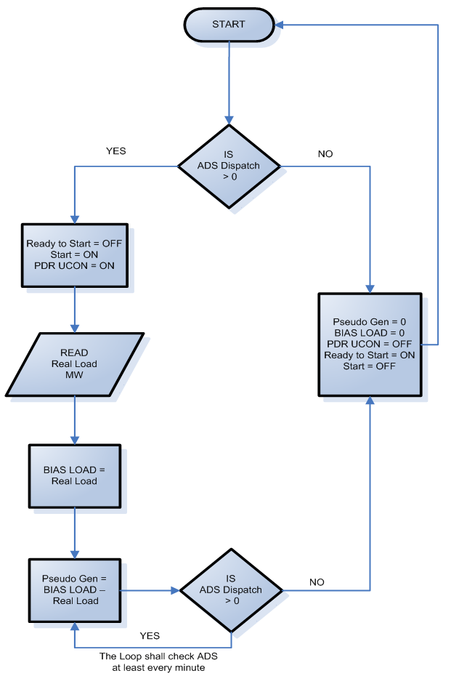

## Timing and Configuration Requirements

Demand Response Provider (DRP) who have PDR resources greater than 10 MW or participate in the Ancillary Service market are responsible for adhering to all the current ISO, DNP3 configuration, and security standards telemetry standards located on the ISO’s Direct Telemetry Web page (see References).

PDR resources are not required to send updated load or generation values to the Real-Time Device every 4 seconds, PDR timing requirement has been extended per provisions set in section 6.2.2 of this BPM. However the Real-Time Device is still required to scan every 4 seconds.

## Analog Data Requirements

### Instantaneous Load (MW)

Definition

Each PDR resource will be required to provide the instantaneous load of each resource. The instantaneous load value is the compensated real-time megawatt load as seen at the ISO grid. This value is either the actual or calculated value of the load where the resource connects to the ISO-Controlled Grid. The value is compensated for losses typically arising from the difference between the measured point and the delivery point (such as transformer losses, and radial line losses). The value should align with the Point-of-Delivery (POD) megawatts calculated or measured by the ISO revenue meters.

Purpose

The purpose of providing this data point is to validate that there is load at the resource. It is also essential in providing a baseline point that is used to calculate the pseudo generation point.

Methods of providing this value

Instantaneous Load data can be gathered from a revenue meter. The individual sites are aggregated up to the resource level. (It can also be gathered from a resources EMS system that tracks electricity consumption at each load point.) All methods for deriving instantaneous load must first be reviewed by ISO engineers before being accepted as a credible load measurement.

### Pseudo Generation (MW)

Definition:

Each PDR resource will be required to provide the pseudo generation of each resource. The pseudo generation will be calculated from the Instantaneous load MW and the PDR UCON points, this is a digital calculated point and is discussed in more detail in section titled “PDR Unit Connectivity Status (PDR UCON)

This pseudo generation calculation must be done in parallel with the PDR UCON calculation. This program contains two independent loops and is configured as follows:

* Validate that the current status of the **PDR UCON** is set to **ON**.
* If the **PDR UCON** is set to **OFF**, then the **Pseudo Gen** point will be set to **0** and the program will look back to **START**.
* If the **PDR UCON** is set to **ON**, then the **BIAS LOAD** point will hold the current value of the Instantaneous Load and keep that value until the program re-executes from **START**.
* Next, the **Pseudo Gen** will be calculated (Pseudo Gen = BIAS LOAD – Instantaneous Load)
* Each time the **Pseudo Gen** is calculated, the program must then validate the current status of the **PDR UCON**.
* If the **PDR UCON** is set to **ON**,then the **Pseudo Gen** will be calculated (Pseudo Gen = BIAS LOAD – Instantaneous Load) and the loop will continue.
* If the PDR UCON is set to OFF, then the Pseudo Gen point will be set to 0 and the program will look back to START.

For example, if the Instantaneous Load at a resource is 100 MW at the instant the PDR UCON is set to ON, then the BIAS point will store the 100 MW in its register. As the load drops to 95 MW, the pseudo generation will be BIAS – Instantaneous Load or 100 – 95 = 5 MW. When the PDR UCON is switched to the OFF status, the pseudo generation resets to 0 MW.

Exhibit 12-3: PDR UCON Status Flowchart

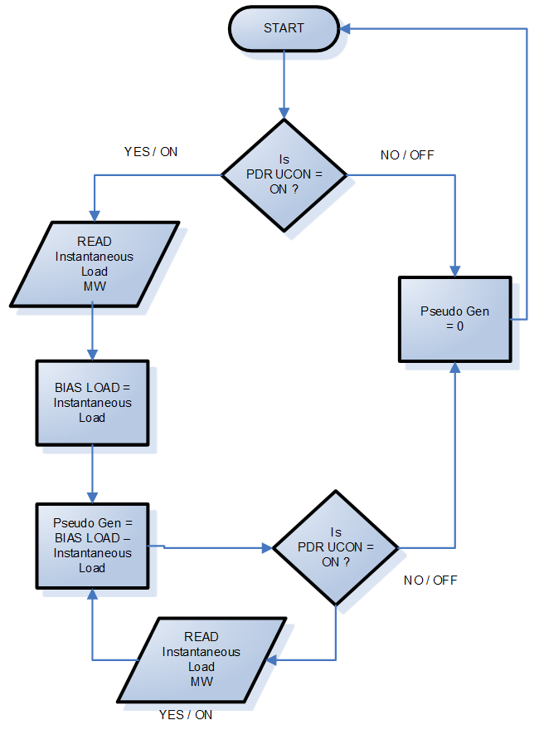

Purpose

It will allow ISO to treat the PDR like an ordinary generator and allow the PDR to participate in Spin and Non Spin ancillary service markets.

Methods of providing this value

This calculation can be performed within a control system, SCADA, EMS, or within a certified Real-Time Device that has been re-certified for inclusion of this calculation.

## Digital Data Requirements

### Load Unit Connectivity Status (LOAD UCON)

Definition

The Load Unit Connectivity Status represents that the PDR has enough load to be dispatched. ON status means that the resource has load greater than 0 MW to be dispatched by the ISO ADS as a pseudo generator. For example if a resource currently has a load of 10 MW, then the LOAD UCON bit will be set to ON. An OFF status means the PDR is at 0 MW of load. Exhibit 12-4 provides a program flowchart.

Exhibit 12-4: Load UCON Status Flowchart



Purpose

The LOAD UCON value is used to determine if the load is available, as a pseudo generator, and can be counted towards Spinning or Non-Spinning Operating Reserve contribution. It provides a check and balance in the state estimator network topology and data quality work. The UCON also provides an indication if the pseudo generator is available for dispatch.

Methods of providing this value:

The UCON status can be programmed within a Real-Time Device, PLC, or a control system.

## PDR Unit Connectivity Status (PDR UCON)

Definition

The PDR UCON in ON status is an indication that the PDR has been dispatched. ISO dispatches for non-regulation resources are normally performed through the Automated Dispatch System (ADS). The PDR UCON can be manually set by an operator based off of an ADS signal. It can also be tied to an application programming interface(API) which automatically sends the ADS dispatch to the Real-Time Device to perform the calculation for the PDR UCON.

1. If the LOAD UCON is set to ON and the resource receives an ADS dispatch greater than 0 MW, then the PDR UCON is set to ON.
2. If the LOAD UCON is set to OFF and the resource receives an ADS dispatch greater than 0 MW, then the PDR UCON is set to OFF.
3. If the LOAD UCON is set to OFF and the resource receives an ADS dispatch of 0 MW, then the PDR UCON is set to OFF.
4. If the LOAD UCON is set to ON and the resource receives an ADS dispatch of 0 MW, then the PDR UCON is set to OFF.
5. In all of these cases, the Program should loop back to Start and re-execute.

Exhibit 13-4 illustrates the flow of this program.

Exhibit 12-5: PDR UCON Status Flowchart



Purpose

The LOAD UCON value is used to determine if the load is available, as a pseudo generator, and can be counted towards Spinning or Non-Spinning Operating Reserve contribution. The PDR UCON value is used as a validity check when counting Operating Reserve contribution. The PDR UCON also provides an indication if the pseudo generator is currently being dispatched. It is also an important point in calculating the pseudo generation MW point.

Methods of providing this value

The UCON status can be programmed within a Real-Time Device, PLC, or a control system.

# Real-Time Device Aggregator

Check sections: Refer to Sections 6.9, 6.10 and 6.11 for other direct telemetry requirements.

## Applicability

The Real-Time Device Aggregator standards in this Section 15 apply to Participating Generators who plan to use a single Real-Time Device to provide direct telemetry for multiple resources. To optimize the data gathering process, resources may use a Real-Time Device Aggregator to meet the ISO’s telemetry requirements instead of installing a Real-Time Device for each facility. The Real-Time Device Aggregator must be a Participating Generator that can enter into agreements with other Participating Generators to provide direct telemetry through its Real-Time Device.

## Real-Time Device Aggregator Responsibility

The Real-Time Device Aggregator is responsible for the real-time telemetry data aggregation and is the main contact for data quality issues, accuracy, and communication.

The Real-Time Device Aggregator will be responsible for coordinating required data points telemetered to the ISO EMS.

In addition to meeting the requirements of Section 5.8 for its own resources, the Real-Time Device Aggregator has the obligation to maintain direct contact with the ISO for all other resources that it is aggregating.

## Real-Time Device Aggregator Authorization

The Real-Time Device Aggregator shall provide a letter on the Real-Time Device Aggregator’s letterhead setting forth a list of all resources that are being aggregated. The letter shall state that the Real-Time Device Aggregator accepts all responsibilities detailed in this BPM. The Real-Time Device Aggregator shall provide accompanying letters from each Participating Generator granting authorization to the Real-Time Device Aggregator to telemeter data on their behalf to the ISO.

# Real-Time Point Definitions

The Participating Generator is responsible for correctly providing all required points at the accuracy herein.

## Analog Values

### Unit Gross Megawatts (Gross MW)

Definition

This quantity is defined as the resource’s real power output, before subtracting the auxiliary real power load or step-up transformer real power losses.

Purpose

Gross MW is used to determine the Balancing Authority Area's generation pattern in the network model.

Methods of providing this value:

This value can be provided from instrument devices at the resource site (accurate transducers), at the Generating Unit terminals/low side of the step-up transformer, before any generation is intermingled with auxiliary load. It may be calculated from other measured points as agreed to by the CAISO RIG Engineer (i.e., Net MW plus Aux MW = Gross MW).

### Unit Net Megawatts (Net MW)

Definition:

This quantity is defined as the resource’s real power output measured at the low side of the step up transformer after the auxiliary transformer if applicable. Or the quantity available after subtracting the unit auxiliary real power load, but before subtracting the unit step-up transformer real power losses.

Purpose:

Net MW is used to determine the CAISO Balancing Authority Area's generation pattern used in the network model.

Methods of providing this value:

This value can be provided from instrument devices at the resource site or it may be calculated from other measured points as agreed to by the CAISO RIG Engineer (i.e., Gross MW minus Aux MW = Net MW).

If Gross MW is equal to Net MW then Net MW is not required.

### Unit Point of delivery Megawatts (POD MW)

Definition:

This quantity is defined as the compensated, real-time value of the resource’s real power output at the point the resource connects to the electric grid to the CAISO Controlled Grid. It should align with the Point-of-delivery (POD) MW calculated or measured by the CAISO revenue meters. This value is either the actual or calculated value of the unit’s output at the point where the Generating Unit connects to the electric grid into the CAISO Controlled Grid. It must be a real time updated value and not averaged over time. This value is compensated for losses typically arising from the difference between the measured point and the delivery point (such as transformer losses, line losses, etc.).

Purpose:

POD MW is used to certify Ancillary Services and represents the Generating Unit’s real power delivery to the system. It is used to validate Ancillary Services Bids (scheduled versus actual) and to calculate accurate Operating Reserves. This point is also used as an input to the real-time network model used for system reliability monitoring.

Methods of providing this value

This value may be obtained by installing instrument devices at the POD. This value may also be calculated by providing an accurate conversion of existing Net MW values to point of delivery values within the existing control system or external system. The value must represent an accuracy of +/-2% of the true value of POD MW represented in the ISO revenue meter.

### Unit Auxiliary Load Megawatts (Aux MW)

Definition

Aux MW is defined as the real power load the Generating Unit provides to maintain its station service power. This point is required where a unit’s maximum auxiliary load is 1 MW or greater. Aux MW cannot represent other loads between the Generating Unit and the POD.

Purpose

The ISO uses this value to determine the amount of replacement power required by each Generating Unit based on unit trips, and startups. This value is used to properly model the Generating Unit’s operating condition.

Methods of providing this value

Aux MW can be provided from instrument devices at the auxiliary transformer. It may be calculated from other measured points as agreed to by the ISO Energy Data Acquisition Specialist (that is, Gross MW minus Net MW = Aux MW).

### Gross Reactive Power or Gross Mega VAR (MVAR)

Definition

This quantity is defined as the unit’s reactive power output, before subtracting the unit auxiliary reactive power load or unit step-up transformer reactive power losses.

Purpose

Gross MVAR is used to determine the ISO Balancing Authority Area's MVAR generation pattern in the network model.

Methods of providing this value

This value can be provided from instrument devices at the generating site (accurate transducers), at the Generating Unit terminals/low side of the step-up transformer, before any generation is intermingled with auxiliary MVAR. It may be calculated from other measured points as agreed to by the ISO Energy Data Acquisition Specialist (that is, Net MVAR + Aux MVAR = Gross MVAR).

### Point of delivery Mega VAR (POD MVAR)

Definition

This quantity is defined as the compensated, real-time value of the reactive power (MVAR) at the point the Generating Unit connects to the ISO-Controlled Grid. It should align with the Point-of-delivery (POD) MVAR calculated or measured by the ISO revenue meters. This value is either the actual or calculated value of the unit’s output at the point where the Generating Unit connects into the ISO-Controlled Grid. It must be a real-time updated value and not averaged over time. This value is compensated for losses typically arising from the difference between the measured point and the delivery point (such as transformer losses, and line losses).

Purpose

POD MVAR is used to establish a generating site’s reactive power delivery to the system and the impact of the generating site on system voltage. It is used to verify the generating site’s operation within ISO Tariff requirements for reactive power, and is used as an input to real-time network model used for system reliability monitoring.

Methods of providing this value

This value may be obtained by installing instrument devices at the POD. This value may also be calculated by providing an accurate conversion of another data point measured at the same voltage level as the POD. The value must represent an accuracy of +/-2% of the true value of POD MVAR represented in the ISO revenue meter.

### Net Reactive Power (Net MVAR)

Definition

This quantity is defined as the unit’s reactive power output after subtracting the unit auxiliary reactive power load, but before subtracting the unit step-up transformer reactive power losses.

Purpose

Net MVAR is used to determine the ISO Balancing Authority Area's generation pattern used in the network model.

Methods of providing this value

This value can be provided from instrument devices at the generating site or it may be calculated from other measured points as agreed to by the ISO Real-Time Device Engineer (that is, Gross MVAR minus Aux MVAR = Net MVAR). If Gross MVAR is equal to Net MVAR then Net MVAR is not required.

### Auxiliary Load Reactive Power (Aux MVAR)

Definition

Aux MVAR is defined as the reactive power load the Generating Unit provides to maintain station service power. This point is required where a unit’s maximum auxiliary load is one MW or greater. Aux MVAR cannot represent other loads between the Generating Unit and the POD.

Purpose

The ISO uses this value to determine the amount of replacement MVAR required by each Generating Unit based on unit trips, and startups. This value is used to properly model the Generating Unit’s operating condition.

Methods of providing this value

Aux MVAR can be provided from instrument devices at the auxiliary transformer. It may be calculated from other measured points as agreed to by the ISO Real-Time Device Engineer (that is, Gross MVAR minus Net MVAR = Aux MVAR).

### Generating Unit Terminal Voltage (KV)

Definition

This quantity is defined as the terminal voltage of the Generating Unit, before the unit step-up transformer. It may be phase to phase or a calculated value of phase to ground multiplied by the square root of three. For a Net Scheduled QF subject to a QF PGA, this quantity is the voltage at the Point of Demarcation.

Purpose

The ISO uses generator terminal voltage to determine each Generating Unit’s contribution to system voltage support. Terminal voltage is critical to proper network modeling. This value is useful in identifying voltage control issues, and MVAR circulation problems.

Methods of providing this value

This value can be provided from instrument devices at the Generating Unit terminals (accurate transducers), or, for a Net Scheduled subject to a NSPGA, at the Point of Demarcation.

### Unit Operating High Limit (UOHL) [AGC Units Only]

Definition

The UOHL represents the maximum physical operating limit of the Generating Unit. The plant control room operator typically sets this limit to prevent the unit MW output from exceeding an upper plant operating limitation.

Purpose

The ISO uses this value to set the maximum boundary for AGC calculations and unit availability at the POD.

Method of providing this value

The real-time UOHL value is typically provided directly from the device that the plant control room operator uses to manually set the operating limits.

### Unit Operating Lower Limit (UOLL) [AGC Units Only]

Definition

The UOLL represents the minimum physical operating limit of the Generating Unit that participates in ACG. The plant control room operator typically sets this limit to prevent the unit MW output from exceeding a lower plant operating limitation.

Purpose

The ISO uses this value to set the minimum boundary for AGC calculations and unit availability at the POD.

Method of providing this value

The real-time UOLL value is typically provided directly from the device that the plant control room operator uses to manually set the operating limits.

## Digital Values

### Unit Generator Breaker

Definition

The generator breaker is the breaker that closes when the unit is synchronized to the grid.

Purpose

The generator breaker positions are needed to determine unit synchronization status.

Method of providing this value

The plant or resource control system can provide the status of the breaker.

The following three digital points are required for resources providing AGC.

### Unit Connectivity Status (UCON)

Definition

The UCON status is an indication that a unit is synchronized to the grid.

Purpose

The UCON value is used as a validity check when counting Operating Reserve contribution. It provides a check and balance in the FNM and provides an indication of the number of Generating Units connected to the system.

Method of providing this value

This value is determined from the actual breaker status points of each Generating Unit and the pre-determined value of Gross MW, point of delivery MW, or the measurement of voltage is greater than a small percentage of Terminal Voltage and the High side breaker closed. If a line breaker exists then it should be included in the UCON calculation as well. Consult with the ISO Energy Data Acquisition Specialist to determine the best solution.

Method of providing this value for battery

This value is determined from the actual breaker status points of each Generating Unit and the inverter ready status. UCON should be ON when the battery is both charging and discharging. Consult with the ISO Energy Data Acquisition Specialist to determine the best solution.

### Unit Control Status (UCTL)

Definition

The UCTL represents a software or hardware switch position that the resource is controlling remotely or locally. The On (High) indicates when the resource is available for remote supervisory control. The Off (Low) indicates the resource is controlled locally.

Purpose

The purpose of the UCTL is to validate whether the resource is providing remote control to supervised control operators.

Method of providing this value:

The resource operator selects the UCTL value through an operator interfacedisplay or physical toggle switches. Whichever method is used to select remote or local control, the indication will come from the resource control system.

### ISO Unit Authority Switch (UASW)

Definition

The Real-Time Device unit authority logic dictates which entity (the Generator, the ISO, or other EMS system) has control over a Generating Unit at any given time. When sharing control of equipment, it is usually necessary to designate and report who has supervisory control of a specific Generating Unit at any given moment. This is done to prevent conflicting commands from being issued to the equipment. Unit authority switching is the means by which control of specific equipment is passed among the various control groups. Any logic or operator action that prevents or acts against the ISO’s direct control will result in this status changing to Off (Low).

Purpose

When UASW is On (High) the resource will only be available for ISO AGC Set Point and no other.

Method of providing this value

The UASW may be defined as a hardware or software switch. In either case, the switch must be available to the resource operator through the plant control system.

### Unit Automatic Generation Control (UAGC)

Definition

The UAGC is the final indication that the resource is ready for the ISO to send AGC Set Points. The AGC resource requires an AGC certification in order to participate in the ISO Regulation market.

There is one UAGC digital point for each Resource ID.

Purpose

This point is used for Settlement purposes to determine that the intended resource met the scheduled generation expectation. When this point is ON (High), the ISO EMS AGC control has authority to send MW Set Points to the Real-Time Device.

Method of providing the value

The UAGC status is a calculation result that is made of digital point operand of AND points UCON, UCTL and UASW. The Set Point shall move the unit within the timing parameters outline herein.

### Automatic Voltage Regulator (AVR) / Power System Stabilizer (PSS) Status

Definition

The AVR is used to automatically control Generating Unit terminal voltage. The status must be represented as ON (in automatic control) or OFF (off-line).

The PSS is the system that works with the AVR to respond to frequency excursions. The status shall be represented as On (in service) or Off (out of service).

Purpose

AVR and PSS device status points are required to assess system reliability. The AVR and PSS status points are required from all Generating Units subject to WECC requirements. These points are also used in post-event analysis and for system stability simulations.

Method of providing this value

These values must represent the ON (high) status from the AVR and PSS devices and may not come from a calculation or user entered value. Data points for AVR and PSS status are not required for units that do not have these devices installed.

### Peaking Unit Ready to Start and Start Statuses

The requirement for these points have been deleted from this BPM -

## Switchyard Values

The Participating Generator may own some or all of the equipment associated with the connected switchyard. All switchyard values must meet telemetry timing requirements. If the Participating Generator owns switchyard breakers, it must provide, through the Real-Time Device, the status retransmitted.

The Participating Generator may own some or all of the equipment associated with the high voltage switchyard interconnecting the resource to the grid. The telemetry of all switchyard equipment (for example, circuit breakers, circuit switchers, motor operated disconnects, transformers, and transmission lines) directly associated with connecting the resource to the grid must be communicated through the Real-Time Device regardless of the interconnecting equipment’s ownership. If the switchyard directly connects to the ISO-Controlled Grid and the Participating Generator owns the other switchyard equipment, the real-time telemetry of all switchyard equipment must be communicated through the Real-Time Device. Where existing telemetry to the ISO is available for this switchyard equipment (that is, provided through the UDC), the ISO will not require the telemetry of this other switchyard equipment to be provided through the Real-Time Device, provided the Participating Generator has arranged and can provide the ISO with evidence of a formal agreement with the UDC to continue to deliver real-time switchyard telemetry values on behalf of the Participating Generator. However, the ISO Energy Data Acquisition Specialist must agree with the specific methods used to provide the real-time telemetry.

### Switchyard Line and Transformer MW and MVAR Values

Definition

The MW and MVAR quantities for the switchyard’s transmission lines and transformers.

Purpose

These values allow for proper network state estimation and assessment of network topology and assist in troubleshooting data quality problems (that is, sum of flows into and out of a bus). The MW and MVAR values are essential for modeling system restoration scenarios.

Method of providing this value

These values are obtained through devices connecting to the line CTs and PTs.

### Switchyard Bus Voltage

Definition

This value is the voltage at the Generating Unit’s switchyard bus. It may be phase to phase or a calculated value of phase to ground multiplied by the square root of three.

Purpose

The switchyard bus voltage is used in determining network state estimation. It identifies voltage concerns and/or system-imposed limitations on reactive support.

Method of providing this value

This value is provided from bus PTs.

### Switchyard Device Status

Definition

The breakers, circuit switchers, and/or motor operated disconnects (MOD) status for each Generating Unit, line, bus, and transformer breakers in the Generating Unit’s switchyard are required.

Purpose:

These values are used in determining network topology for state estimation. They are required for system restoration and outage information. In some arrangements, they may be the basis for forming the UCON status.

Method of providing this value

These values are direct measurements from switchyard devices and/or device auxiliary contacts.

### Aggregated Units

In certain situations, the ISO allows aggregation of Generating Units and the associated telemetry. This is typically done where Generating Units are operated in an interrelated manner (such as through use of a common watershed, and operation in combined cycle configuration). In these situations it is important to work with the ISO Energy Data Acquisition Specialist to determine the required data points. The following provides a guideline to help determine the necessary and correct data points for Aggregated Units.

### Aggregated Gross MW and MVAR

This is a calculation of the sum of the individual unit Gross MW and Gross MVAR values. When applicable, Gross MW and MVAR are still required for the individual Generating Units. Requirements will vary on a case-by-case basis.

### Aggregated Net MW and MVAR

This is a calculation of the sum of the individual unit Net MW and Net MVAR values. When applicable, Net MW and MVAR are still required for the individual Generating Units. Requirements will vary on a case-by-case basis.

### Aggregated Aux MW and MVAR

This is a calculation of the sum of the individual unit Aux MW and Aux MVAR values. When applicable, Aux MW and MVAR are still required for the individual Generating Units. Requirements will vary on a case-by-case basis.

### Aggregated Point of Delivery MW

Aggregated Point of Delivery (POD) MW is a required point and is typically the value of the MW at the point of interconnection to the ISO-Controlled Grid. In this case, individual Generating Unit POD MW and MVAR are not required.

### Aggregated Point of Delivery MVAR

This point requirement has been removed from this BPM

### Aggregated Unit Connectivity (UCON)

Aggregated UCON is calculated from the status of all individual Generating Unit UCONs. For example, Aggregated UCON = Unit 1 UCON OR Unit 2 UCON. Individual Generating Unit UCON is based on a determination that at least one of the individual units’ breakers is closed and that a minimum threshold of unit Terminal Voltage or Gross MW is exceeded. Coordinate with a ISO Energy Data Acquisition Specialist for calculation.

### Aggregated Peaking Unit Start and Ready to Start

This point requirement has been removed from this BPM

## Wind and Solar Point Definitions

The EIR owner must provide the following applicable real-time data points for the technology used. Reference appendix Q section 3 of the ISO tariff for the additional required real-time points for a VER resource.

### Direct Irradiance (DIRD)

Direct Irradiance can be measured with a pyranometer or equivalent equipment which measures solar irradiance in watts per meter (W/m2). All equipment used to measure solar irradiance must have an accuracy of ± 25 W/m2. Direct solar irradiance is a measure of the rate of solar energy arriving at the earth's surface from the sun's direct beam, on a plane perpendicular to the beam, and is usually measured by a sensor mounted on a solar tracker. The tracker ensures that the sun's beam is always directed into the instrument's field of view during the day.

### Global Horizontal Irradiance (GHIRD/GHI)

Global Horizontal Irradiance can be measured with a pyranometer or equivalent equipment which measures solar irradiance in watts per meter (W/m2). All equipment used to measure solar irradiance must have an accuracy of ± 25 W/m2. The GHIRD/GHI is the total solar radiation (direct, diffuse, and ground-reflected irradiance) hitting the horizontal surface of the earth. The sensor shall be mounted on a meteorological station, set at the global horizontal angle of the earth in reference to the sun solar radiation.

### Global Irradiance / Plane of Array Irradiance (PAIRD)

Plane of array irradiance can be measured with a pyranometer or equivalent equipment which measures solar irradiance in watts per meter (W/m2). All equipment used to measure solar irradiance must have an accuracy of ± 25 W/m2. The sensor shall be mounted on a meteorological station, facing the same angle and direction as all other solar photovoltaic panels at the site.

### Diffused Irradiance

Diffuse irradiance refers to all the solar radiation coming from the sky and other reflected surfaces except for solar radiation coming directly from the sun and the circumsolar irradiance within approximately three degrees of the sun.

* **Diffused Plane of Array Irradiance (DPOA):** Diffused plan of array irradiance sensors follow the same accuracy and mounting requirements as the GPOA sensors but shall be designed to measure diffused irradiance.
* **Global Diffused Irradiance (DIFGH):** Global diffused irradiance sensors follow the same accuracy and mounting requirements as the GHI sensors but shall be designed to measure diffused irradiance.

### Back Panel Temperature (BPTEMP)

Back panel temperature is measured in degrees Celsius, with an accuracy of one degree. The temperature sensor should be mounted behind a solar photovoltaic panel.

## Battery Point Definitions

The EIR owner must provide the following applicable real-time data points for the technology used. Section 6.1 provides a table of the required real-time points for each type of technology.

### Instantaneous State Of Charge (SOC)

The Instantaneous SOC is the amount of energy in MWh that the battery, in real time, has available for ISO participation. The SOC will be maintained within energy limit constraints (minimum and maximum) defined in the ISO Master File. Data should be updated every four seconds and should vary from zero to maximum energy limit.

### Maximum Continuous Energy limit

The Maximum Continuous Energy Limit is the maximum energy in MWh that can be stored in the battery for ISO participation. When the Participating Generator provides this value through telemetry, Market dispatch will respect the energy limit. This value cannot be above the maximum energy limit defined in the ISO Master File. The derate should be reflected, when applicable, in real time.

# Sub-LAP Resource Names

Table 15-1: Sub-LAP Resource Names

| **DESCRIPTION** | **RESOURCE NAMES** |
| --- | --- |
| PGCC Central Coast | SUB LAP_PGCC |
| PGEB East Bay (Bay Area) | SUB LAP_PGEB |
| PGF1 Fresno | SUB LAP_PGF1 |
| PGFG Geysers | SUB LAP_PGFG |
| PGHB Humboldt | SUB LAP_PGHB |
| PGLP Los Padres | SUB LAP_PGLP |
| PGNB North Bay | SUB LAP_PGNB |
| PGNC North Coast | SUB LAP_PGNC |
| PGNV North Valley | SUB LAP_PGNV |
| PGP2 Peninsula (Bay Area) | SUB LAP_PGP2 |
| PGSA Sacramento Valley | SUB LAP_PGSA |
| PGSB South Bay (Bay Area) | SUB LAP_PGSB |
| PGSF San Francisco (Bay Area) | SUB LAP_PGSF |
| PGSI Sierra | SUB LAP_PGSI |
| PGSN San Joaquin | SUB LAP_PGSN |
| PGST Stockton | SUB LAP_PGST |
| SCE Core (LA BASIN) | SUB LAP_SCEC |
| SCNO SCE North | SUB LAP_SCEN |
| SCEW SCE West | SUB LAP_SCEW |
| SCHD High Desert | SUB LAP_SCHD |
| SCLD Low Desert | SUB LAP_SCLD |
| SCNW SCE Northwest | SUB LAP_SCNW |
| SDG1 San Diego | SUB LAP_SDG1 |